2 Operation of power engineering system

Keywords: energy, work, heat, power, efficiency, load chart, load chart covering, baseload, semi peaks, peaks.

2.1 Basic quantities and units
Energy is defined as ability of a physical system to do a work. This scalar quantity (in power engineering) can be measured indirectly using other quantity - power. The energy can be also calculated from a load chart.
Any form of energy can be transformed into another form however there are strict limits to the efficiency of the conversion. Also matter can converted to energy and vice versa energy can be convered into matter. These principles are used in power engineering units for generation of electricity and/or heat.
Work is defined as a transfer proces of energy from one physical system onto another.
$ΔE=W$ [J] [2.1.]
Heat is again defined as energy transferred from one physical system to another, but only using a thermal interaction. In contrast to work, heat is always accompanied by a transfer of entropy. Terms heat flow and heat transfer can be interchangeably used instead of heat. Sum of heat and work defines the energy transfer more generally.
$ΔE=W+Q$ [J] [2.2.]
Acording to SI, the accepted unit of energy is joule [J]. Joule is used in power engineering to measure thermal energy. To measure electric energy, specific unit kilowatt hour [kWh] is used in power engineering.
$1\text{kWh}=\text{3600}∗{\text{10}}^{3}J$ [2.3.]
Power is the rate or speed at which energy is transferred, used, or transformed. Acording to SI, the unit of power is watt [W] defined as joule per second (J/s).
$W=j∗s^{−1}$ [2.4.]
Efficiency is a physical measurable and quantitative ratio of an output to an input. Maximum efficiency is theoretically 1, practically a number between 0 and 1. Output energy is always lower than input energy. So efficiency, higher than 1, can be never reached (perpetuum mobile).
$η=\frac{Q_{\text{IN}}}{Q_{\text{OUT}}}$ [-] [2.5.]
This quantity is a dimensionless number or percents may be used in some specific cases [%].
Difference between input energy and output energy is waste energy (losses).
$Q_{\text{IN}}=Q_{\text{OUT}}+Q_{\text{LOS}}$ [J] [2.6.]

2.2 Load chart
Load chart or supply curve is a diagram showing the amount of electrical energy used by a customer (or produced by a producer) during given course of time. Power producers use this important tool to predict future consumption and to control required production in the future.
Only several time courses are used in power engineering. The most important period is one day. The diagram is called daily load chart and it is used for short term predictions. Annual load chart is used for long term prediction and for planning general maintenance and/or repairs of large units. One week load chart and seasonal load chart complete the set.
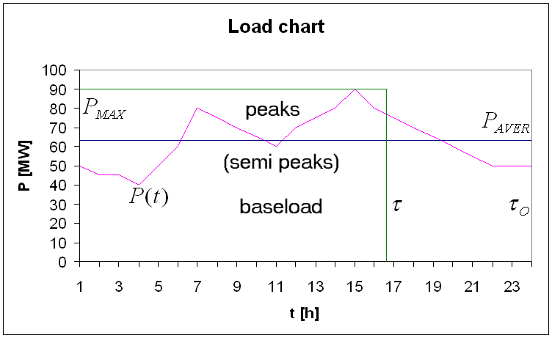
Fig. 2.1.: Load Chart
Produced energy is a total amount of energy produced according to the load chart. Area under supply curve on the chart is equal to produced energy.
$E=\int_{t=0}^{τ_{0}}{P(t)\text{dt}}$ [J] [2.7.]
Utilisation time says how long, must a power station produce energy at full power, to produce the same amount of energy as according to the load chart.
$E=\int_{t=0}^{τ_{0}}{P(t)\text{dt}}=P_{\text{MAX}}τ$ [h] [2.8.]
Average power is an average value of produced power presented in the load chart.
$E=\int_{t=0}^{τ_{0}}{P(t)\text{dt}}=P_{\text{MAX}}τ=P_{\text{AVER}}τ_{O}$ [W] [2.9.]
Maximum power is a peak value of produced power presented in the load chart [W].
Installed power or nameplate power is a nominal value of power of the unit (power station) [W].
Capacity factor is the ratio between average power from the load chart and installed power of the power station.
$μ_{\text{CAP}}=\frac{P_{\text{AVER}}}{P_{\text{INS}}}$ [-] [2.10.]
Load factor is the ratio between average produced power and maximum power produced according to the load chart.
$μ_{\text{LD}}=\frac{P_{\text{AVER}}}{P_{\text{MAX}}}$ [-] [2.11.]
Utilization factor is the ratio between maximum power produced acording to the load chart and installed power of the power station.
$μ_{\text{UTIL}}=\frac{P_{\text{MAX}}}{P_{\text{INS}}}$ [-] [2.12.]
Availability factor is the ratio between time that power station is able to produce energy over a period and total amount of time in the period.
$μ_{\text{AVLB}}=\frac{τ_{\text{AVLB}}}{τ_{0}}$ [-] [2.13.]
Operational efficiency is the ratio between total produced energy and total potential energy that could have been produced in the period.
$μ_{\text{OPER}}=\frac{E_{\text{PRODUCED}}}{E_{\text{MAX}}}$ [-] [2.14.]
Economic efficiency is the ratio between complete production costs (fuel, labor, materials, services etc.), and produced energy.
$μ_{\text{ECON}}=\frac{C_{\text{COSTS}}}{E}$ [Kc/kWh] [6.15.]

2.3 Load chart covering
Load chart covering means a strategy of power supply from a set of different units. These units have usually different installed power and features. Main features affecting the strategy are regulation abilities, economic costs and influence on environment.
Any load chart can be divided into to two or three sections. Lower sector is called baseload and means the constant level of energy continuosly needed across all the time period. Upper sector describing oscillations of the load curve is called peaks or spikes. Border between these sectors is not defined exactly and some literature defines the border area as semi peaks.
Except peaking offer some power plants other ancillary services. Blackstart recovery is the ability to be brought back to service after a power outage. Fast reserve means usage of power plant in standby to replace possible lost units. Frequency service helps to guarantee required quality of the energy.

2.3.1 Baseload power stations
Baseload power plants are power plants devoted to the production of baseload supply. These units are used to meet some or all of the continuous energy demand. Production of these units is not changed to match all power demands since it is usually more economical to produce energy from these units at a constant rate, meaning low costs relative to other units available to the system. Baseload plants usually have very high fixed costs, high plant load factor and very low marginal costs.
Typical set of baseload plants includes nuclear, coal fired and oil fired power stations. Conventional and pondage run of the river hydro power stations also usually serve as baseload plants. Among the renewable energy sources, such as solar, wind, biomass, small hydroelectric, geothermal etc. can in specific conditions also provide baseload power.
Baseload power plants are usually large units and cover majority of the power produced in the grid. Baseload units typically run at all times through the period except the scheduled maintenance and/or general repairs. Each baseload power plant is allotted specific amount of the baseload power supply. This amount is calculated from the load duration curve of the unit (typically 35 - 40% of the maximum load).

2.3.2 Peaking power stations
Peaks in the load chart are usually handled by smaller and more responsive units called peaking power plants. These plants can be cycled up and down to match fast fluctuations in consumption, although it means relatively high costs. These units are characteristic with low fixed costs, low plant load factor but high marginal costs. These units are usually gas turbines, accumulation and pumped storage hydro power plants.
Off-peak demand is considered to be the opposite for peaks. Power demand is relative low and the redundand energy produced by baseload plants is usually used in pumped storage power stations. Also off-peak rates, remote switching and timing duty cycles of suitable devices are often used to stimulate the energy demand in these intervals.
2.4 Exercise
- Explain the term “energy”. What units are used for quantification?
- Explain difference between terms “work” and “heat”.
- Explain the term “power”. What units are used for quantification?
- Explain the term “efficiency” and its theoretical and practical limitations.
- Explain the term “load chart” and concretize time periods used in power engineering. What is the main reason for recording of the load chart?
- Explain load chart covering and main features affecting the strategy. What power stations are used as baseload plants and peaking plants?
- Draw a load chart from given table. Calculate produced energy, maximum power, average power and utilization time.
time [h] | 1 | 2 | 3 | 4 | 5 | 6 | 7 | 8 | 9 | 10 | 11 | 12
P [MW] | 51 | 46 | 44 | 41 | 49 | 61 | 76 | 71 | 66 | 61 | 71 | 76
time [h] | 13 | 14 | 15 | 16 | 17 | 18 | 19 | 20 | 21 | 22 | 23 | 24
P[MW] | 82 | 88 | 81 | 74 | 69 | 64 | 59 | 56 | 54 | 53 | 52 | 52

2.5 Answers
- Scalar quantity describing the ability of a physical system to do a work. The only accepted unit, acording to SI, is joule [J]. Specific unit kilowatt hour [kWh] is used in power engineering to measure electric energy.
- Work is a transfer proces of energy from one physical system onto another. Heat is also an energy transfer from one physical system to another, but only using a thermal interaction, and is also always accompanied by a transfer of entropy.
- Power describes the speed of an energy transfer, usage or transformation. The only accepted unit, acording to SI, is watt [W].
- Efficiency describes a ratio between an output and an input. Output energy must be in all real applications lower than input energy. It means that efficiency is a number from interval <0; 1). Efficiency can theoretically, but only theoretically reach the value 1.
- Load chart is a diagram displaying the amount of electrical energy used by a customer (or produced by a producer) during given course of time. Periods of one day, one week and one year are used in power engineering. Load chart is used for prediction of future consumption of energy.
- Load chart covering means a strategy of power supply from different units. Main features affecting the strategy are regulation abilities, economic costs and influence on environment of the power stations. Typical baseload plants are nuclear, coal fired and oil fired power stations, conventional and pondage run of the river hydro power stations. Also renewable energy sources can be used as baseload plants. Peaking power stations are usually gas turbines, accumulation and pumped storage hydro power plants.
- Equation 2.9. can be used for the calculations. Because of discrete dataset, integral can be replaced with a sum.
$E=\sum_{t=0}^{τ_{O}}{P(t)}Δt=P_{\text{MAX}}τ=P_{\text{AVER}}τ_{O}$ [MWh] [2.16.]
E = 1497 MWh; P_{MAX} = 88 MW; P_{AVE} = 62,4 MW; τ_{O} = 16,6 h

