6 Thermodynamics of water steam

Keywords: Rankine cycle, efficiency of Rankine cycle, steam superheating, steam reheating, regenerative features, water steam.

6.1 Ideal Rankine cycle
Conversion of heat into work is described by the rankine cycle. Power source for the cycle is an external heat, what is supplied to a closed loop with some carrier medium (mostly clean water). Combustion of fossil fuels and nuclear fission are the two most common heating processes used as power source for this cycle. Usage of this cycle provides about 90% of electric power generated in the world (coal-fired and oil-fired power stations, nuclear power plants, biomass and solar thermal power stations) and also allowed expansion of steam engines in 19th century. The cycle is named after William John Rankine, a Scottish scientist and Glasgow University professor.
Rankin cycle is actually a practical example of Carnot cycle. There are two main differences to Carnot cycle. The heat addition in the boiler or reactor is isobaric and also rejection in the condenser is isobaric. Both processes in the theoretical Carnot cycle are isothermal.
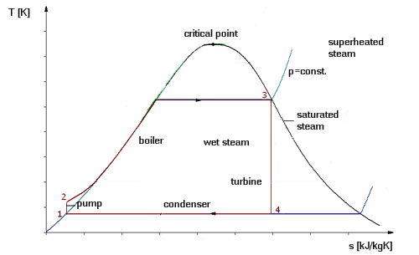
Fig. 6.1.: Rankine cycle
As presented on the TS diagram shown on Fig. 6.1., there are four main stages in the Rankine cycle.
- Stage 1-2: the working medium in liquid state is pumped from lower to higher pressure. The pump stage requires some input of energy.
- Stage 2-3: the preassurised liquid medium enters boiler in the point 2. Here it is heated at constant pressure to dry saturated steam. The heating stage requires energy from an external heat source.
- Stage 3-4: the dry saturated steam expands in a turbine and transfers its energy. This process decreases the temperature and pressure of the steam and some condensation may occur. Output work is generated.
- Process 4-1: the wet steam enters condenser in the point 4. Here it is condensed at a constant temperature and changes state to saturated liquid.
Work of the pump is defined as difference of enthalpies in the point 2 and point 1 from the diagram.
$w_{\text{pump}}=i_{2}−i_{1}$ [J/kg] [6.1.]
Input heat entering the cycle in the boiler is defined as difference of enthalpies in the point 3 and point 2 from the diagram.
$q_{\text{in}}=i_{3}−i_{2}$ [J/kg] [6.2.]
Work of the turbine is defined as difference of enthalpies in the point 3 and point 4 from the diagram.
$w_{\text{turbine}}=i_{3}−i_{4}$ [J/kg] [6.3.]
Waste heat leaving the cycle in the condenser is defined as difference of enthalpies in the point 4 and point 1 from the diagram.
$q_{\text{waste}}=i_{4}−i_{1}$ [J/kg] [6.4.]
Each value of enthalpy h₁ - h₄ for water steam cycle can be calculated from IS chart or from steam tables.
There are two most important factors affecting efficiency of the Rankine cycle – the working medium and used materials. Maximum pressure of the working medium in liquid state cannot reach super critical levels (22 MPa for water). Maximum temperatures are limited by the creep limit of turbine blades (typically 400 – 650 °C for stainless steel) and condenser temperatures (typically around 30 °C). These temperatures give a theoretical Carnot efficiency about 63% while modern coal-fired power stations reach real efficiency about 42%.
The pump used in stage 1-2 pressurizes the working medium from the condenser in liquid state instead of gaseous state, because pumping of the liquid medium throught the cycle requires much less energy then compression of the gas. All the energy used for pumping the working medium through the complete cycle is lost. Using the condensation of the medium, the work required by the pump consumes only 1% or 3% of the turbine power. The condenser significantly contributes to higher efficiency of the real cycle.
Work of the turbine and pump and input heat defines the thermodynamic efficiency of the cycle.
$η_{\text{therm}}=\frac{W_{\text{turbine}}−W_{\text{pump}}}{Q_{\text{in}}}$ [-] [6.5.]
Also most of the energy used for vaporization of the working medium in the boiler in stage 2-3 is lost to the cycle. Condensation that can run up in the turbine is limited to about 10% in order to minimize the erosion of turbine blades and the rest of vaporization energy is rejected from the cycle through the condenser.
The working medium in the Rankine cycle is constantly reused in a closed loop. Clean water is usually used in the Rankine cycle, while different substances could be also used, because of its favorable thermodynamic properties, availability, low costs and nontoxic and nonreactive chemistry. Some organic fluids such as acetone or toluene allow usage of Rankine cycle with low temperature heat sources (70 – 120 °C) such as solar thermal collectors. The cycle is then called Organic Rankine Cycle (ORC). The name means only marketing strategy but no special physical principle. Efficiency of the cycle in this case is much lower as a result of the smaller temperature range, but this is balanced with low costs of earning heat at these low temperatures.
Relatively low temperatures on the turbine entry (compared with a gas turbine) are also the reason for common usage of the Rankine cycle as the final cycle in combined-cycle gas turbine power stations.

6.2 Real Rankine cycle
The pumping and expanding stage in the ideal Rankine cycle would be isoentropic. It means that pump and turbine are ideal and generate no entropy. Processes 1-2 and 3-4 are represented by vertical lines on the T-S diagram, so that the cycle more closely resembles the Carnot cycle. But the compression by real pump and the expansion in real turbine in a real steam cycle are not isoentropic. The entropy is increased during these processes so that the processes are non-reversible. The power required by the pump is a bit higher and the power generated by the turbine is a bit lower then in ideal cyclus.
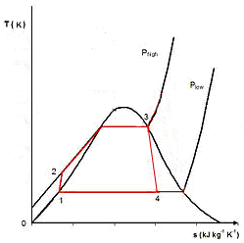
Fig. 6.2.: Real Rankine cycle

6.3 Enhancing the Rankine cycle
The efficiency and service life of the steam turbine would be decreased by water droplets after partial condensation of the steam. The drops would hit the turbine blades at very high speeds, what could cause progressive degradation of the blades.

6.3.1 Steam superheating
The easiest way to avoid this issue is the steam superheating. Original finishing point of the heating process (stage 2-3) is located just on the curve of saturated steam. Additional heating (superheating) process 3-3’ shifts the diagram more to the right and evokes production of drier steam during expansion 3’-4’.
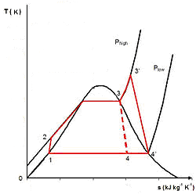
Fig. 6.3.: Real Rankine cycle with superheating
This process is commonly utilized in steam power stations as the final stage of the heating process in the upper most part of the boiler.
6.3.2 Steam reheating
Different way to prevent the vapor from condensation during long expansion is steam reheating. In this case, two turbines work in series. Steam from the boiler enteres the first turbine, expandes during stage 3’-4’, is reheated in the boiler during stage 4’-5 and expandes in the second (low pressure) turbine during stage 5-6. More of the heat flowin the Rankine cycle with reheating occurs at higher temperature, what again increases the efficiency of the cyclus.
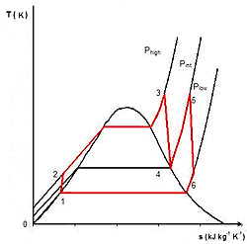
Fig. 6.4.: Real Rankine cycle with reheating

6.3.3 Regenerative features
Some other features to increase cycle efficiency and economy are commonly used in real thermal power stations. These features, called regenerative features, effectively increase the nominal heat input temperature of the cycle.
Heating of the cold feed water is realized in regenerative feed water preheater, what decreases the heat addition at relatively low temperatures in the boiler. Direct contact heating means that working medium emerging from the condenser is preheated by mixing with the steam bleeded from the hot part of the cycle. Closed feed water heating means that working medium emerging from the condenser is preheated by the steam bleeded between turbine stages in an ordinary tubular heat exchanger.

6.4 Water steam
Heating means any heat addition causing some increase of the temperature.
Vaporization means the change from liquid state to gaseous state.
Evaporation means free vapor generation on the liquid surface in open space at any temperature.
Boiling means vapor generation on and under the liquid surface.
Vaporization heat means the amount of heat necessary for vaporization at boiling temperature.
Vapors are gaseous states not corresponding Boyle-Gay-Lussac law.
Wet steam means a mixture of boiling water in saturated liquid state and saturated vaporized steam. Wet steam is generated by amount of heat lower than vaporization heat at preasure and temperature of boiling.
Saturated steam means homogenous amount of the steam generated by addition of vaporization heat at preasure and temperature of boiling.
Superheated steam means saturated steam with temperature higher than the temperature of boiling. Superheated steam is generated from saturated steam by additional amount of heat.
Critical point means the boundary between liquid and gaseous state on the curve of saturated steam.
Dew point means the temperature on the surface of a device, when the water vapors start to condensate.

6.5 Exercise
- Explain the term “vaporization heat”.
- Explain difference between terms “vaporization” and “evaporation”.
- Explain difference between terms “saturated steam”, “wet steam” and “superheated steam”.
- Explain ideal Rankine cycle on TS diagram and describe all phases of the cycle.
- Explain difference between Rankine cycle with reheating and Rankine cycle with superheating.
- Explain the term “Organic Rankine cycle”.
- Calculate the efficiency of the ideal cycle in thermal powerstation. Steam enteres turbine with pressure P_{a} = 6,5 MPa and temperature t_{a} = 430 °C. Temperature of condensed liquid water is t_{kd} = 37 °C. Use IS diagram of water steam.

6.6 Answers
- Vaporization heat means the heat necessary for vaporization a liquid at boiling temperature.
- Vaporization means common process of any change from liquid state to gaseous state, while evaporation means free generation of vapor on the liquid surface in open space at any temperature.
- Saturated steam means homogenous steam generated by addition of vaporization heat at boiling temperature. Wet steam means a mixture of boiling saturated liquid water and saturated vaporized steam. Superheated steam means saturated steam with temperature higher than the temperature of boiling.
- Rankine cycle describes a conversion of heat into work with an external power source of heat looped with some carrier medium. The cycle is used in many types of power stations such as coal-fired and oil-fired power stations, nuclear power plants, biomass and solar thermal power stations. The Rankine cycle is presented on the TS diagram by four main stages. Stage 1-2 describes the pumping of working medium in liquid state from lower to higher pressure with addition of some input energy. Stage 2-3 describes the heating of liquid medium in the boiler at constant pressure to dry saturated steam with addition of heat from an external source. Stage 3-4 describes the expansion of the dry saturated steam in a turbine. Output work is generated. Process 4-1 describes condensation of the wet steam to saturated liquid at a constant temperature in the condenser. Waste heat goes along this stage.
- Both cases describe a possible increase of the Rankine cycle efficiency. Steam reheating is shown on diagram 6.4. Steam from the boiler enteres the first turbine where it expandes (stage 3’-4’), then is reheated in the boiler (stage 4’-5) and again expandes in the second turbine (stage 5-6). Steam superheating is shown on diagram 6.3. Original finishing point of the heating process (point 3) is shifted from the curve of saturated steam more to the right (point 3’) what evokes production of drier steam during expansion 3’-4’.
- The name means only marketing strategy for a Rankine cycle using some organic fluid as working medium to usage of the cycle with low temperature heat sources. ORC is used for example in solar thermal collectors.
- Find the intersection of isobaric curve at 65 MPa with isothermic curve at 430 °C in the IS diagram of water steam. Read the enthalpy of the steam entering the turbine (i_{a} = 3245 kJ/kg).
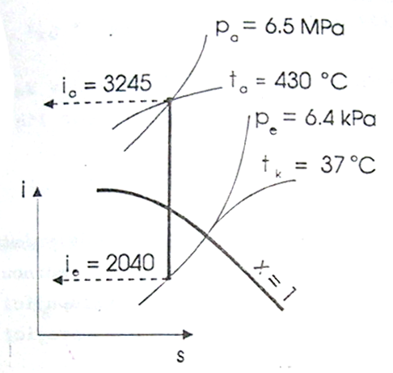
Fig. 6.5.: Reading the IS diagram of water steam
Then look for conditions in the condenser. Find the intersection of isothermic curve at 37 °C with the curve of saturated steam. In this point read the value of pressure in the condenser (Pe = 6,4 kPa).
The steam expands isoentropically from the pressure Pa to pressure Pe. Intersection of the expansion line with the isobaric curve at 6,4 kPa show the enthalpy of the emmision steam (ie = 2040 kJ/kg). Diference between i_{a} and i_{e} defines the ideal isoentropic gradient of the turbine h_{ad}.
$h_{\text{ad}}=i_{a}−i_{e}=\text{3245}−\text{2040}=\text{1205}{\text{kJ}}/{\text{kg}}$ [6.6.]
Difference between enthalpy of the steam entering the turbine and the enthalpy of condensed liquid water defines the input heat.
$i_{\text{kd}}=t_{\text{kd}}∗c_{p}=\text{37}∗4,\text{17}=\text{155}{\text{kJ}}/{\text{kg}}$ [6.7.]
$q_{\text{input}}=i_{a}−i_{\text{kd}}=\text{3245}−\text{155}=\text{3090}{\text{kJ}}/{\text{kg}}$ [6.8.]
Efficiency of the cycle can be then calculated as ratio between the output work (ideal isoentropic gradient) to the input heat.
$η=\frac{h_{\text{ad}}}{q_{\text{input}}}=\frac{\text{1205}}{\text{3090}}=\text{38}\text{\%}$ [6.9.]
The efficiency is 38%.

