7 Thermal power stations

Keywords: thermal power station, steam power station, boiler, steam turbine, condenser, technological schema, main operative media.

7.1 Thermal power stations
A thermal power station is a type of power station that burns chemical combustibles to produce electricity. Coal, natural gas and oil, as representatives of fossil fuels, are the mostly used fuels. Biomass, biogas and liquid bio fuels, as representatives of renewable energy sources complete the family.
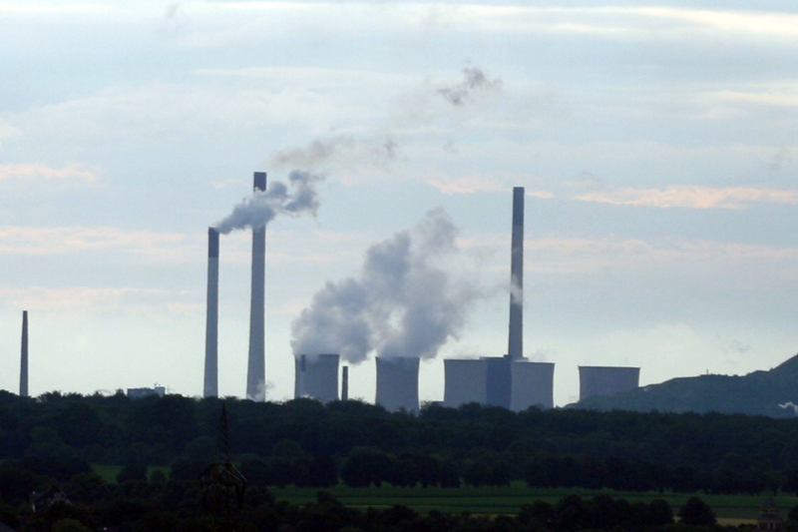
Fig. 7.1.: Harten thermal power station (Germany)
A thermal power station uses energy conversion in 3 sequential steps. At first, the chemical energy of a combustible is converted into heat. Secondly, the heat is converted into mechanical energy that is finally converted into electricity. The heat is generated during burning processes in a boiler, burning chamber or fuell cell, the mechanical energy is convereted from heat during gas expansion in some type of rotating machine, which finally operates an electrical generator to produce the electricity. The rotating machine can be a steam turbine, a gas turbine or a piston engine.
Thermal power plants with steam turbines are usually designed on a large scale and for continuous operation to supply baseload. Power stations with gas turbines are used as fast responding units for peaking. Power plants with combustion engines and fuell cells are usually small units for local supply or cogeneration. Thermal plants usually provide the most of produced electricity.
Relatively accessible fuels and longtime developed technologies are the main advantages of the thermal plants. But these qualities are redeemed with some unfavourable byproducts. Waste heat remaining due to the finite efficiency of real thermodynamic cycles is released directly to the environment (atmosphere, cooling water from river, lake or sea, evaporated water from cooling towers, etc.). Flue gas from combustion of fossil fuels is discharged directly to the atmosphere and contains solid pollutants (fly ash), gas pollutants such as nitrogen, nitrogen oxides, sulfur oxides and also carbon dioxide and water vapour. Particulate matter can be harmful and have negative health impacts (irritation of small airways, asthma, chronic bronchitis, airway obstructions, respiratory and cardiac mortality, etc.). Nitrogen and sulfur oxides can react with moisture in the atmosphere and create acidic compounds such as sulfurous acid, nitric acid and sulfuric acid causing acid rains. Carbon dioxide and water vapour are one of the major contributors to the greenhouse effect. Also some radioactive isotopes such as uranium or thorium and some heavy metals such as mercury can be traced in the flue gas and increase pollution and radiation. Massive landscape devastation incidenting extraction and transport of combustibles supported with large amount of solid wastes from burning (ash, cinder, etc.) are the next serious issues. And finally, the total efficiency is relatively low - typically about 30 – 40%…
Some effective techniques have been developed for decreasing the negative influence and for greening the thermal power stations. Total efficiency can be increased by partial usage of waste heat in regenerative features or during simultaneous cogeneration of electricity and heat. Building the power plant in close neighbourhood of a fuel source (mine) and recultivation can limit the landscape devastation. Solid wastes can be reused as materials for building industry or road constructions. Usage of bag house and electrostatic precipitator reduces the emissions of solid pollutants. Application of denitrification and desulphitisation of the flue gas restricts the emissions of gas pollutants. And finally carbon capture and storage methods are being developped.

7.2 Technological scheme of steam power station
Rankine cycle describes the physical principle of typical steam thermal power station.
Basic technological scheme consists of boiler, steam turbine, condenser and main feeding pump.
Next important auxiliary components are cooling circuit with cooling towers, chimney with separators and various additional machinery.
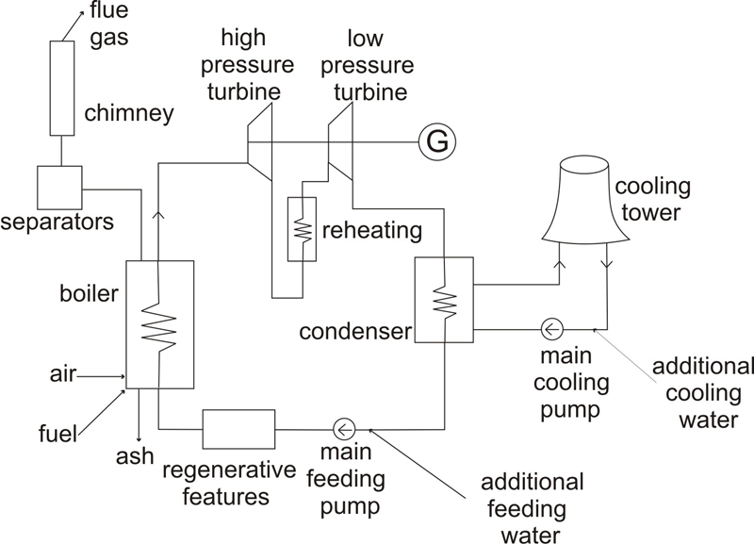
Fig. 7.2.: Basic technological scheme of steam power station

7.2.1 Boiler
A combustible (coal) is burned with air supply in a boiler, the chemical energy of the combustible is converted into a heat and transferred into a working media (water).
Preasurized feedwater is warmed at constant pressure upto boiling temperature, converted into to a saturated steam and superheated.
Flue gas and solid noncombustible wastes are generated. Flue gas is drained away via flueduct through separators into a chimney, while ashmatter is deposited onto dumping ground.
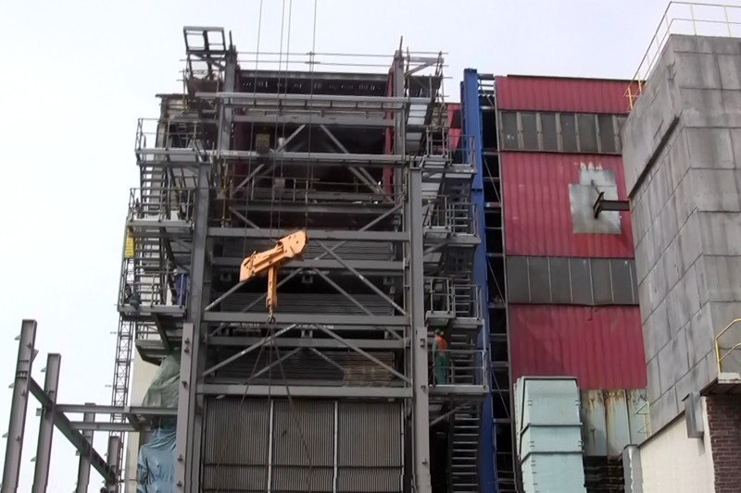
Fig. 7.2.: Boiler (Pilsen heating plant)
Grating furnace boiler is the oldest type and it is not used for power engineering any more. Its efficiency is relatively low.
Pulverized coal boiler has better efficiency and is the most utilized boiler in power engineering. Pulverized coal is supplied in the jet of primary combustion air.
Fluid boiler can burn low quality combustibles with minimal environmental impacts.
7.2.2 Turbine
Superheated steam enteres a turbine where it expands. The heat of the steam is converted into a mechanical energy of the turbine rotor and next in a generator into electricity. The steam looses temperature and pressure close to condensing point.
Utilized steam turbines are usually reaction axial high speed machines. Small power units are often single stage and single casing turbines, while larger units are usually multi stage and multi casing turbines.
Condensing turbines and designed for steam extraction at low pressures (vacuum).
Back pressure turbines (non-condensing) are designed for final exhaust at withdrawal pressure. These turbines offer withdrawal of the steam for further usage and are often used in heating plants.
Fig. 7.3.: Turbine (Pilsen heating plant)
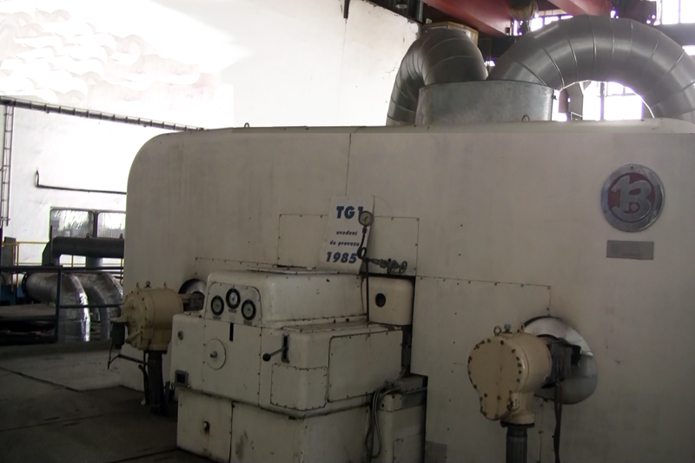
7.2.3 Condenser
Superheated Wet steam from the turbine enteres a condenser, where the condensation at constant temperature is finshed. Condenser is a heat exchanger, where the latent heat proceeds from the steam circuit into the cooling circuit.

7.2.4 Main feeding pump
Main feeding pump draws the condensed water from the condenser, pressurises it and closes the steam circuit back into the boiler. Looses of the feeding water are supplemented from the feedwater tank.

7.2.5 Regenerative features
The steam circuit in larger plant is typically enhanced with steam reheating between the high pressure stage and the low pressure stage turbines.
Additional regenerative features for feedwater preheating further enhance the total efficiency of the plant.
7.2.6 Cooling circuit
Typicall cooling circuit transfers the latent heat from the condenser into cooling towers, where the heat is transfered into the atmosphere. Cooling water pump provides the circulation of cooling water between the cooling towers and the condenser. Amount of cooling water that is evaporated in cooling towers is supplemented from the cooling water tank.
Cooling towers can be designed as wet or dry. Wet towers are more efficient, but have large consumption of cooling water. Water is directly sprayed into agitated air. Produced steam screen can affect local microclimate such during often fogs, icing, agricultural land shading, etc. Dry towers work as normal heat exchanger water – air. Efficiency is lower, but environmental impact is smaller. The most efficient cooling is flow cooling. Cooling water is fed to the condenser directly from a stream or sea. High environmental impact limits the usage.
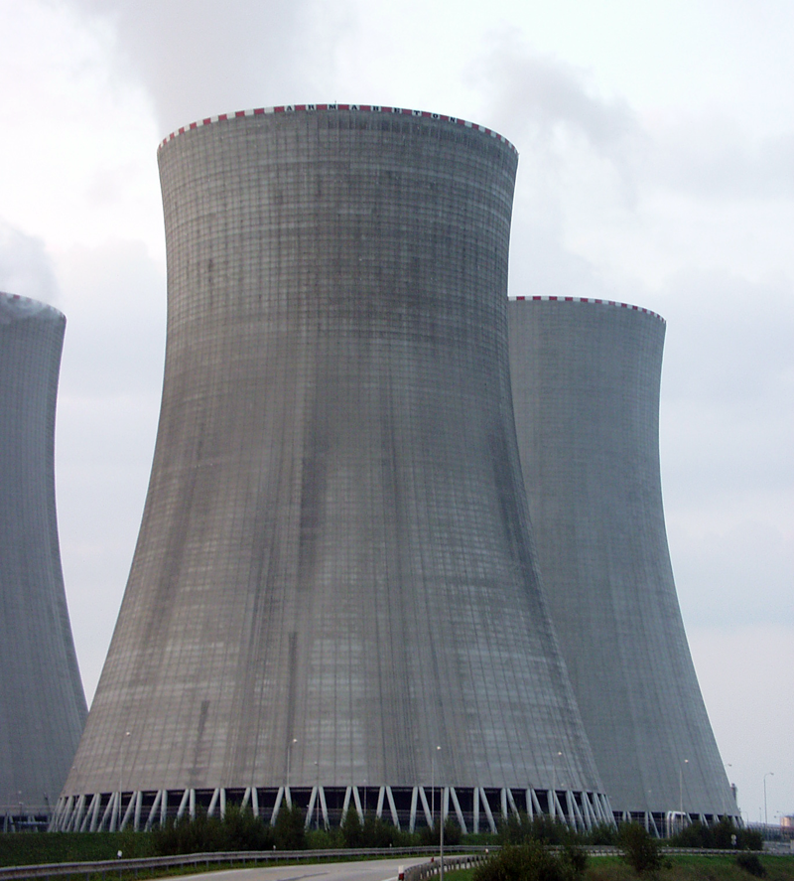
Fig. 7.4.: Wet cooling tower (Prunerov thermal power plant)

7.2.7 Additional machinery
The plant is usually completed with additional machinery such as water service, fuel transporters, conveyor belts, cracking mills, feed coal pulverizers, air fans, chimney, pollutant separators, etc.

7.3 Main operative media of steam power station
Main operative media of usual steam power station are coal as a fuel, air (oxygen) as an oxidizing agent, feeding water as a working medium, cooling water as a coalant and flue gas and ash as wastes.

7.3.1 Coal
Coal is usually delivered by coal trains. Modern train unloaders use rotary devices that swivels each carriage upside down to dump the coal, while all the train is still coupled together. If the plant is built close to a coal mine, coal pipeline or conveyors are used to deliver the coal. Highway trucks can be used as an additional way to support smaller amout of combustible, typically wood chips or biomass. Large colier ships may be also used in favourable locations.
The coal from unloaders is then stored on the coal yard with large reserve to bridge a possible gap between the deliveries.
The coal is prepared for use in coal mills by crushing the rough coal to pieces less about 5 cm in size. Then is the coal transported by conveyor belts from the coal yard to coal silos. The silos feed coal pulverizers that grind the coal to powder consistency. The coal powder is then mixed and preheated with primary combustion air which transports it to the boiler furnace.
For starting up, the plant usually uses fuel oil as well. The oil is usually stored in vertical cylindrical steel tanks.
The energy realesed from the combustion processes in the furnace can be expressed with equations of the complete combustion. Also calorific value, amount of oxygen and the stechiometric air to fuel ratio are defined by stechiometric equations 7.1., 7.2. and 7.3.
$\begin{aligned}C+O_{2}→{\text{CO}}_{2}+\text{33828},5{\text{kJ}}/{\text{kg}} \\ 1\text{mol}+1\text{mol}→1\text{mol} \\ \text{12}g+\text{22},\text{39}{\text{dm}}^{3}→\text{22},\text{26}{\text{dm}}^{3}\end{aligned}$ [7.1.]
$\begin{aligned}2H_{2}+O_{2}→2H_{2}O+\text{119615}{\text{kJ}}/{\text{kg}} \\ 2\text{mol}+1\text{mol}→2\text{mol} \\ 4,\text{032}g+\text{22},\text{39}{\text{dm}}^{3}→\text{44},8{\text{dm}}^{3}\end{aligned}$ [7.2.]
$\begin{aligned}S+O_{2}→{\text{SO}}_{2}+\text{9250}{\text{kJ}}/{\text{kg}} \\ 1\text{mol}+1\text{mol}→1\text{mol} \\ \text{32},\text{06}g+\text{22},\text{39}{\text{dm}}^{3}→\text{21},\text{89}{\text{dm}}^{3}\end{aligned}$ [7.3.]
Except the combustible components, the coal also contains significant volume of ashmatter and water.
If the amount of oxygen is lower than the stechiometric air to fuel ratio, incomplete combustion occurs. This is very unpleasant effect that decreases the efficiency and increases the fuel consumtion. Some components remain unburnt and further contaminate the flue gas.
$\begin{aligned}C+\frac{1}{2}O_{2}→\text{CO}+\text{32847}{\text{kJ}}/{\text{kg}} \\ 1\text{mol}+\frac{1}{2}\text{mol}→1\text{mol} \\ \text{12}g+\text{11},2{\text{dm}}^{3}→\text{22},4{\text{dm}}^{3}\end{aligned}$ [7.4.]
Combustion is a compex set of exothermic chemical reactions between a combustible and an oxidant agent. In fact, the combustion process runs as a chain reaction in several stages. For most fuels (coal including) pyrolysis occurs before combustion and partial incomplete combustion can occur. This fact is important only during the initiation phase of the burning process, while for ordinary calculations, the stechiometric equations give sufficient results.
The amount of coal is defined by the average thermal power of the power station P_{t} during the period τ and the calorific value of the coal q_{coal}. Thermal power can be calculated from the electric power P_{el} and the efficiency η.
$m_{\text{coal}}=\frac{P_{t}⋅τ}{q_{\text{coal}}}=\frac{P_{\text{el}}⋅τ}{η⋅q_{\text{coal}}}$ [kg] [7.5.]

7.3.2 Air
Large air fans blow the combustion air into the fireplace where it serves as the oxidizing agent for burning processes.
The amount of dry air can be calculated from the oxygen volume in the air (21 %) and the stechiometrical amount of oxygen V_{O} calculated from the stechiometric equations 7.1., 7.2. and 7,3.
$V_{\text{min}}=0,\text{21}⋅V_{O}$ [m³kg⁻¹] [7.6.]
The atmospherical air contains some amount of water vapors increasing its volume. This volume depends on the relative humidity φ, atmospherical pressure P_{A} and the pressure of saturated steam at given temperature P_{S}.
$V_{\text{atm}}=V_{\text{min}}+V_{\text{vapor}}=V_{\text{min}}+ϕ⋅\frac{P_{S}}{P_{A}−ϕ⋅P_{S}}$ [m³kg⁻¹] [7.7.]
The amount of oxygen is primary defined by chemical structure of the combustible. Because of the nonhomogenity of burned mixture formed from air and pulverized coal, some additional air is necessary to allow complete combustion of all fuel. This amount α is typically 20 % of the stechiometric air to fuel ratio.
$V_{\text{air}}=α⋅V_{\text{atm}}$ [m³kg⁻¹] [7.8.]
To avoid complicated calculations according to stechiometrical equations, approximate Rosin equations can be used for various combustibles. The calorific value of the combustible q can be measured in a calorimeter.
$V_{\text{atm}}=0,5+1,\text{012}⋅\frac{q_{\text{coal}}}{\text{4187}}$ [m³kg⁻¹] [7.9.]
$V_{\text{atm}}=1,7+0,\text{88}⋅\frac{q_{\text{oil}}}{\text{4187}}$ [m³kg⁻¹] [7.10.]
$V_{\text{atm}}=−0,\text{28}+1,\text{09}⋅\frac{q_{\text{gas}}}{\text{4187}}$ [m³m⁻³] [7.11.]

7.3.3 Feeding water
Steam operating the turbine is generated in the boiler from the feeding water. Because of very aggressive scene, such as high temperatures, high pressures, high speeds, etc., only absolutely clean water can be used for the feeding.
The amount of steam is defined by the average thermal power of the power station P_{t} during the period τ and the enthalpy of the steam i_{S}.
$m_{\text{steam}}=\frac{P_{t}⋅τ}{i_{S}}=\frac{P_{\text{el}}⋅τ}{η⋅i_{S}}$ [kg] [7.12.]
Cleaning, neutralisation, demineralization, deionization and other physical-chemical processes necessary to prepare the feeding water are so complicated and expensive, that the feeding water must be continuosly reused and only small leaks and looses (3 – 5 %) must be recruited from the reserve tank as supplementary feeding water.

7.3.4 Cooling water
Cooling water works in very different conditions from the feeding water. Temperatures, pressures and speeds are low, but cruical issue is the large volume necessary for exhaust of the latent heat from the condenser. Moreover, usage of the wet cooling tower means massive evaporation and looses of cooling water. Recruiting this amount with expensively prepaired feed water is not economical. Supplementary cooling water is cleaned only from mechanical impurities and is supplied from close reservoir or river.
The amount of cooling water can be calculated from the heat balance of the condenser. Amount of steam m_{steam} with enthalpy i_{e} condenses into water with enthalpy i_{kd}. This specific heat must be equal to the specific heat transferred into cooling water that is expressed with calorimetric equation, where amount of cooling water m_{cool} with heat capacity c_{p} is heated from temperature t₁ to temperature t₂.
$q=m_{\text{steam}}⋅(i_{e}−i_{\text{kd}})=m_{\text{cool}}⋅c_{p}⋅(t_{2}−t_{1})$ [J] [7.13.]

7.3.5 Flue gas and solid noncombustible wastes
Flue gas from the burning processes must completely leave the fireplace. The exhaust is usually supported by natural draught of tall chimney. Flue gas passes at first through pollutant separators before it enteres the chimney. Solid particles are separated in the bag house and electrostatic precipitator, while the volume of sulfur and nitrogen oxides is reduced during desulphitisation and denitrification processes.
The amount of flue gas can be calculated according to stechiometrical equations or approximate Rosin equations can be used for various combustibles. The calorific value of the combustible q can be measured in a calorimeter.
$V_{\text{flue}\text{min}}=1,\text{375}+0,\text{95}⋅\frac{q_{\text{coal}}}{\text{4187}}$ [m³kg⁻¹] [7.14.]
$V_{\text{flue}\text{min}}=1,\text{11}⋅\frac{q_{\text{oil}}}{\text{4187}}$ [m³kg⁻¹] [7.15.]
$V_{\text{flue}\text{min}}=0,\text{446}+1,\text{09}⋅\frac{q_{\text{gas}}}{\text{4187}}$ [m³ m⁻³] [7.16.]
The amount of flue gas must be converted according to real condition (temperature T and pressure p). Volume V₀ means the volume at reference conditions (temperature T₀ and pressure p₀).
$V_{\text{flue}}=V_{0}⋅\frac{T}{T_{0}}⋅\frac{p_{0}}{p}$ [m³ kg⁻¹] [7.17.]
Solid noncombustible wastes, cinder, ash and results of desulphitisation process are continuosly transported from the fireplace to the dumping ground with sufficient capacity.
The capacity of the dumping ground for period τ (3 years) can be calculated from the amount of solid noncombustible wastest m_{ash} that depends on the structure of the coal.
$m_{\text{dump}}=m_{\text{ash}}⋅m_{\text{coal}}⋅τ$ [kg] [7.18.]

7.4 Other types of thermal power stations
Open cycle power plants (simple cycle) using single gas turbine without the steam cycle, are sometimes installed as emergency or peaking plants. Thermal efficiency is much lower and running costs are higher.
Combined cycle power plant combines the Brayton cycle of a gas turbine with the Rankine cycle of a heat recovery steam generator (HRSG). The gas turbine of this power station is primary fueled with natural gas, synthetic gas or fuel oil and followed with the steam turbine. Thermal efficiency of these power plants reaches about 60%. These plants are easier to built then conventional steam power stations, but the cost of fuel heavy influences their economics.
Power stations with piston engines (typically diesel engines) are often used for power suply in communities not connected to a power grid. Also emergency power generators may use internal combustion engines. An alternative to internal combustion engines is the Stirling engine with external combustion. Notwithstanding its advantages is this solution relatively rare.
High temperature fuel cells (molten carbonate or solid oxide FC) can be used as source of the heat for steam cycle.
Combined heat and power (CHP) or cogeneration means the use of a power station to provide electric power and heat. Production of the heat can decrease the efficiency of electricity generation, but dramatically increases the total efficiency (up to 80 %). This technology is often used in municipal or metropolitan heat and power plants. Trigeneration is cogeneration plant complemented of a cooling unit supplying sufficient cooling power for air conditioning or technological purposes.

7.1 Exercise

- Explain the energy conversion in thermal power station.
- What is the main usage of thermal power stations?
- Specify the main disadvantages of thermal power plants.
- Describe basic technological schema of typical steam power station.
- Explain the term “additional air”.
- Calculate the amount of air necessary for complete burning 1 kg of combustible, if the additional air is 20 %, humidity 80 % and ambient temperature 20 °C. Chemical components of the combustible:
C: 58,68 % (M = 12) ash: 15,75 %
H₂: 4,85 % (M = 4,032) water: 8 %
S: 2,15 % (M = 32,06)
O₂: 10,57 % (M = 31,98)
- Explain the difference between feed water and cooling water.
- Calculate approximate amount of operating media necessary for production 1 kWh in steam power station with efficiency 30 %. Combustible calorific value is 12 000 kJ/kg, steam enthalpy 3 400 kJ/kg, specific heat transfer in condenser 2 370 kJ/kg and cooling water heating is 10 °C.
- Explain the term “cogeneration” and specify the efficiency.

7.2 Solutions

- Primary chemical energy of a combustible is converted into electricity in thermal power station in 3 sequential steps. Firstly, the chemical energy is converted into heat during burning processes in a boiler, burning chamber or fuell cell. Secondly, the heat is converted into mechanical energy during gas expansion in some type of rotating machine (steam turbine, gas turbine or combustion engine). Final conversion into electricity proceeds in electrical generator driven by the rotating machine.
- Steam thermal power plants are usually designed for continuous operation to supply baseload. Fast responding power stations with gas turbines are used for peaking. Power plants with reciprocating engines or fuell cells are usually used for local power supply or cogeneration.
- Main disadvantages of thermal power staions are waste heat released directly to the environment, flue gas containing solid pollutants, gas pollutants, water vapour and carbon dioxide, massive landscape devastation, amount of solid wastes and relatively low final efficiency.
- Basic technological schema of steam power station consists of boiler, turbine, condenser and main feeding pump. Additional elements are steam reheaters, regenerative features, cooling circuit and supplementary machinery.
- Additional air is an amount of air necessary to clean burning of all fuel, required by the nonhomogenity of burned mixture pulverized coal and air. The number is typically about 20 % of the stechiometrical ratio.
- Stechiometriacal amount of oxygen can be calculated according to equation 7.1., 7.2. and 7.3. minus content of oxygen in combustible.
$V_{O}=\frac{\text{22},4}{\text{12}}⋅C+\frac{\text{22},4}{4}⋅H_{2}+\frac{\text{22},4}{\text{32}}⋅S−\frac{\text{22},4}{\text{32}}⋅O_{2}=1,\text{31}$ [m³kg⁻¹] [7.19.]
Amount of dry air can be calculated according to equation 7.6. as Vmin = 6,223 m³kg⁻¹.
Atmospherical pressure P_{A} is approximately 1*10⁵ Pa and pressure of saturized steam can be found in steam tables or steam chart P_{S} = 2,3*10³ Pa, so that amount of atmospherical air can be calculated according to equation 7.7. as V_{atm} = 6,345 m³kg⁻¹.
Inclusion of the additional air 20 % means the final neccessary amount of air V_{air} = 7,614 m³kg⁻¹.
- Only absolutely clean water can serve as feeding water because of very aggressive ambient (high temperatures, high pressures, high speeds, etc.). Preparation of the feed water is so complicated and expensive, that the feeding water must be continuosly reused and only small leaks and looses are usually recruited. Cooling water is massively evaporated in cooling towers and recruiting of this large amount allows only basic preparation to keep costs low.
- The amount of coal can be calculated from equation 7.5.
$m_{{\text{coal}}/1\text{kWh}}=\frac{1\text{kWh}}{q_{\text{coal}}}=\frac{\text{3600}J}{η⋅q_{\text{coal}}}=1$ [kg/kWh] [7.20.]
The amount of steam or feeding water can be calculated from equation 7.12.
$m_{{\text{steam}}/1\text{kWh}}=\frac{1}{i_{S}}=\frac{\text{3600}}{η⋅i_{S}}=3,6$ [kg/kWh] [7.21.]
The amount of cooling water can be calculated from equation 7.13. Heat capacity of cooling water is 4187 J/kg.
$m_{{\text{cool}}/1\text{kWh}}=\frac{m_{\text{steam}}⋅(i_{e}−i_{\text{kd}})}{c_{p}⋅(t_{2}−t_{1})}=\frac{3,6⋅\text{2370}}{4,\text{187}⋅\text{10}}=\text{204}$ [kg/kWh] [7.22.]
- Cogeneration or combined heat and power (CHP) means simultaneous production of electricity and heat. Total efficiency of this power plant can reach up to 80 %, although the efficiency of electricity generation can be decreased.

