9 Hydro power stations

Keywords: hydro power plant, water wheel, water turbine, Francis, Kaplan, Pelton, sucker, cavitation, energy potential of water stream, flow duration curve.

9.1 Hydro power stations
Hydro power station is a type of power station that uses the energy of water to produce electricity. The energy can be utilized from a water stream or from a sea. The energy of the sea needs specific devices that are, more or less, only under research and don’t serve as practical plants.
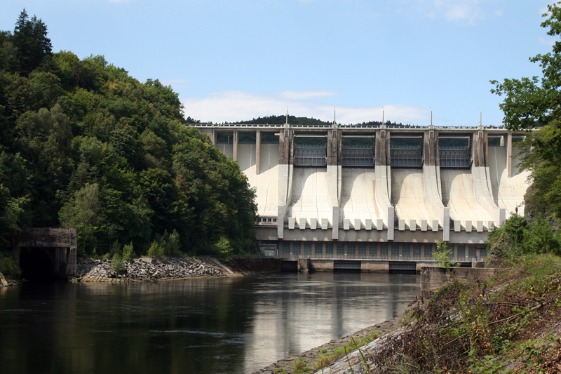
Fig. 9.1.: Slapy hydro power station
Hydro power stations built on streams can be categorized according to several aspects (operation mode, head, power, swelling device, etc.). Hydro power plants have high dispatchability what means that they can come on line very quickly (typically within few seconds). That makes these plants very efficient at covering the peaks in electrical demand.
9.1.1 Operation mode of hydro power station
Conventional hydro power station utilizes approximately total amount of the flow equally during the time. Pondage run of the river plant has some reservoir that can be utilized for the stream regulation purpose. Nonpondage run of the river plant has no reservoir and cannot be utilized for the stream regulation purpose. Installed power match the energy potential of the location.
Accumulation hydro power station uses some reservoir to accumulate the water during the non peak period. During the peak, the accumulated water is utilized to produce electricity. Installed power is higher then energy potential of the location.
Pumped storage hydro power station doesn’t produce electricity, but is used to store the energy. The plant has usually two reservoirs with some gradient. During the non peak period, the water is pumped from the lower lake to the upper reservoir. The plant is operated as a pump and consumps redundant electricity from the grid. During the peak, the pumped water is released from the upper lake to the lower reservoir and is utilized to produce electricity. The plant is operated as power station.

9.1.2 Head of hydro power station
- low pressure hydro power station: head is lower than 20 m
- medium pressure hydro power station: head is between 20 and 100 m
- high pressure hydro power station: head is higher than 100 m

9.1.3 Installed power of hydro power station
- small hydro power station: installed power is lower than 10 MW
- middle hydro power station: installed power is between 10 and 200MW
- large hydro power station: installed power is larger than 200 MW

9.1.4 Swelling device of hydro power station
Large power station utilizes a dam to swell the lake. Gravitational dam is built from rock fill what makes the purchase costs very favourable. Concrete dam can be more compact, but requires sufficient underbed for anchoring.
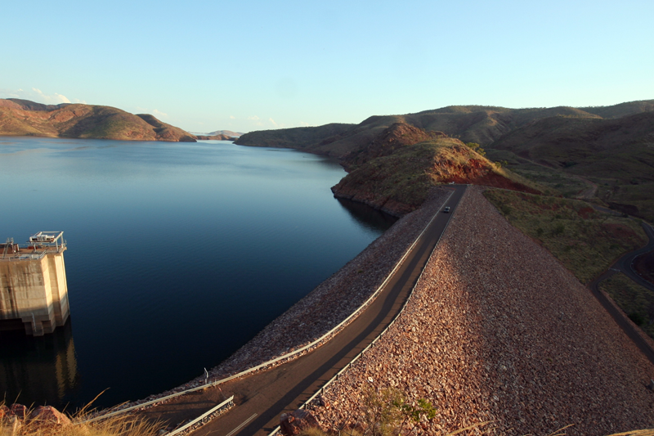
Fig. 9.2.: Gravitational dam (Lake Argyle, Western Australia)

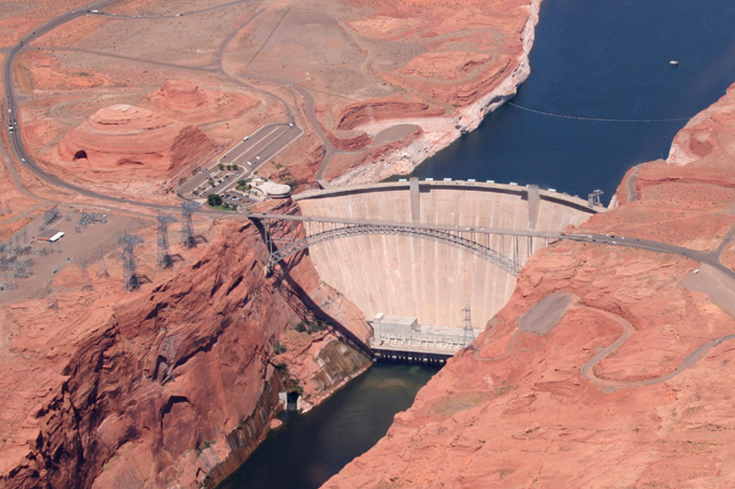
Fig. 9.3.: Concrete dam (Glen Canyon, Arizona)

Small power stations utilize a weir to increase the head, not to swell the pond.
Other way to get sufficient head is use of a derivational canal. No reservoir is established and the water is diverted from a higher location through an artifitial canal with minimal gradient to location of the power station.

9.2 Hydraulic engines
Excluding interesting piston hydraulic engines or hydraulic spirals, there are two basic types of used hydraulic engines – water wheels and water turbines.

9.2.1 Water wheels
Water wheels are unjustly often missed out. They are historically the oldest and constructionaly the most primitive impulse engines. Their robust construction with simple runner is neither sensitive for mechanical impurities (sticks, leaves, ice drift, etc.) nor for variable water level. Levelling of upper and lower level during floods doesn’t almost affect the output power, although it decreases the efficiency. Decreased flow rate during droughts is partially compesed with increased efficiency because of lower splatter, so that the output power is not affected as dramatically as at turbines. Efficiency of water wheels is usually lower, but can also reach 85 %. Wheel is usually low speed machine with high momentus that can be operated at very low head (only few centimeters or less). Non covered wheels can freeze during winter.
Ridge tile downstream wheel is the most primitive wheel utilizing kinetic energy of down stream water. Water spatter on flat paddles evokes only low efficiency (30 – 35 %), but utilized head can be vanishing as only fast flowing water. This construction was also utilized to power the paddle steamers.
Poncelet wheel is the evolution of the downstream wheel. Paddles are bended to minimize the watter spatter. Efficiency is 60 – 65 % and utilized head can be also vanishing as only fast flowing water.
Bucket upstream wheel is the most efficient wheel utilizing kinetic and potential energy of up stream water. Charging buckets in upper position use the kinetic energy of the stream, while full buckets in frontal position use the potential energy of the charge. Efficiency is 60 – 80 % and can be improved to 80 % through revers motion. Utilized head is 2 – 5 m but wheel must not wade the lower level.
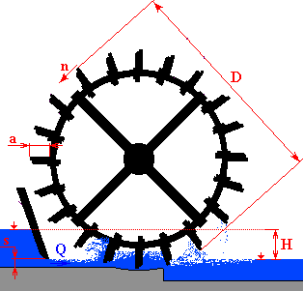
Fig. 9.4.: Principle of downstream water wheel

Design of the water wheel is usually based on empirical equations. Type of the wheel and the diameter depends mostly on the utilized head h.
$D=3÷5⋅h$ [m] [9.1.]
Revolution speed depends on the diameter D and drifting speed u.
$n=\frac{\text{60}⋅u}{π⋅D}$ [rpm] [9.2.]
Drifting speed depends on the theoretical discharge speed c expressed with the head h. The speed is limited with discharge coefficient μ (typically 0,4).
$u=μ⋅c=μ⋅\sqrt{2⋅g⋅h}$ [ms⁻¹] [9.3.]
Paddle width depends on the flow Q, drifting speed u, paddle charge e (basicly 50 % thus 0,5) and the Redtenbacher coefficient r.
$b=\sqrt{\frac{Q⋅r}{e⋅u}}$ [m] [9.4.]
Paddle depth depends on the paddle width and the Redtenbacher coefficient r.
$a=\frac{b}{r}$ [m] [9.5.]
Redtenbacher coefficient can be calculated from the head h and the flow Q.
$r=1,\text{75}⋅\sqrt[3]{\frac{h⋅Q⋅ρ}{\text{75}}}$ [-] [9.6.]
Paddle spacing depends on the paddle depth a.
$t=0,\text{75}⋅a+0,1$ [m] [9.7.]
Paddle number depends on the paddle spacing t and the circumference of the wheel o expressed through the diameter D.
$L=\frac{o}{t}=\frac{π⋅D}{t}$ [-] [9.8.]

9.2.2 Water turbines
Water turbines are usually high speed reaction machines utilizing two sets of blades. Stator blades work as distribution blades that regulate the water to a runner. Turbines have complicated design and are very sensitive on alternations of water level and mechanical impurities in the water. Efficiency is usually much higher than of water wheels and machines are more compact. Turbines can have axial, radial-axial, diagonal, tangential or centripetal water flow and vertical, horizontal or slope axis. Flow through the turbine must be in the regulation range defined as minimal and maximal charge Q_{min} and Q_{max}.
Many types have existed during history, but nowadays 3 or 4 basic types are being utilized in power stations.
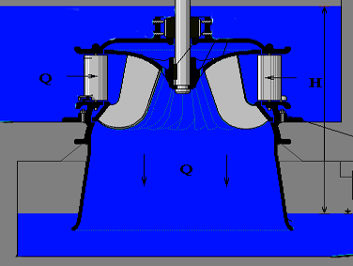
Francis turbine is the longest utilized turbine. The machine belongs to reaction radial-axial type and can be use either as vertical or as horizontal. The runner has fixed blades evokes a bell. The regulation is enabled through swivelled distribution blades. Utilized head varies between meters and hundreds meters, what makes the Francis turbine the most universal engine. The machine can run in reverse mode as a pump, what is often exploited in pumped storage power stations. Turbine is usually supplemented with a sucker for increasing the efficiency.

Fig. 9.5.: Principle of Francis turbine

Kaplan turbine is the youngest utilized turbine. The machine belongs to reaction axial type and can be use either as vertical or as horizontal. The runner evokes the screw propeller. Turbine has very large capability for regulation because of adjustable both - distribution and runner blades so that efficiency can be very high in wide range of the flow. Regulation features produce complicated mechanical design and evoke higher costs. Typical use of this turbine is on smaller heads but large flows that can be very variable. At high flows, more compact parameters results for Kaplan then for Francis. Turbine is also usually supplemented with a sucker. Cheaper modification with fixed runner blades is called propeller turbine.
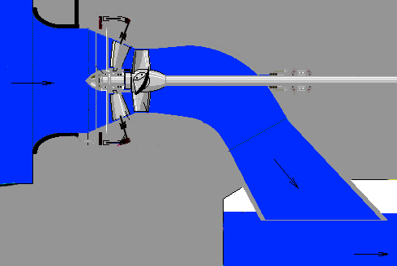
Fig. 9.6.: Principle of Kaplan turbine

Pelton turbine is the most utilized impulse turbine of tangential type. Water is distributed through high pressure jets onto dish shaped blades. Regulation is enabled through the jet’s aperture. Stream deflection allows fast cut down. The turbine is usually built as horizontal machine, but for some small application can be built also as vertical machine. Pelton Turbine it most effective for high water pressure, what is achieved through high head up to few thousands meters.
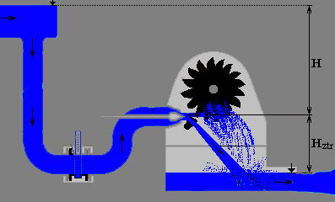
Fig. 9.7.: Principle of Pelton turbine
Banki turbine is impulse turbine of horizontal tangential type with double discharge through the runner. The machine can be succesfully utilized at smaller streams. Regulation is enabled through a flap in the intake object.
Reaction turbines are often used with a sucker. This device enables arbitrary position of the turbine. The runner doesn’t need to be on the lower water level to utilize complete head, if a discharge tube is appended behind. The turbine utilized the pressure between the upper level and the runner and also the underpressure between the runner and the lower level. The water column in the tube creates a draught. Gradually expanding discharge forces the water flow faster and creates further underpressure what creates additional “virtual” head and further increases the efficiency.
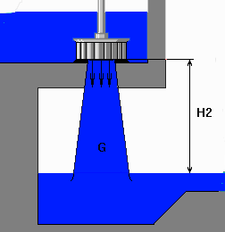
Fig. 9.8.: Principle of sucker
Sucker is relativelly easy to calculate and design. Length depends on the diameter of the runner (input) d_{r} and on the discharge diameter (output) d_{d}.
$l=\frac{d_{d}−d_{r}}{0,\text{17}}$ [m] [9.9.]

Discharge diameter depends on the flow Q and the head h.
$d_{d}=\sqrt{\frac{4⋅Q}{π⋅\sqrt{0,\text{78}⋅h}}}$ [m] [9.10.]

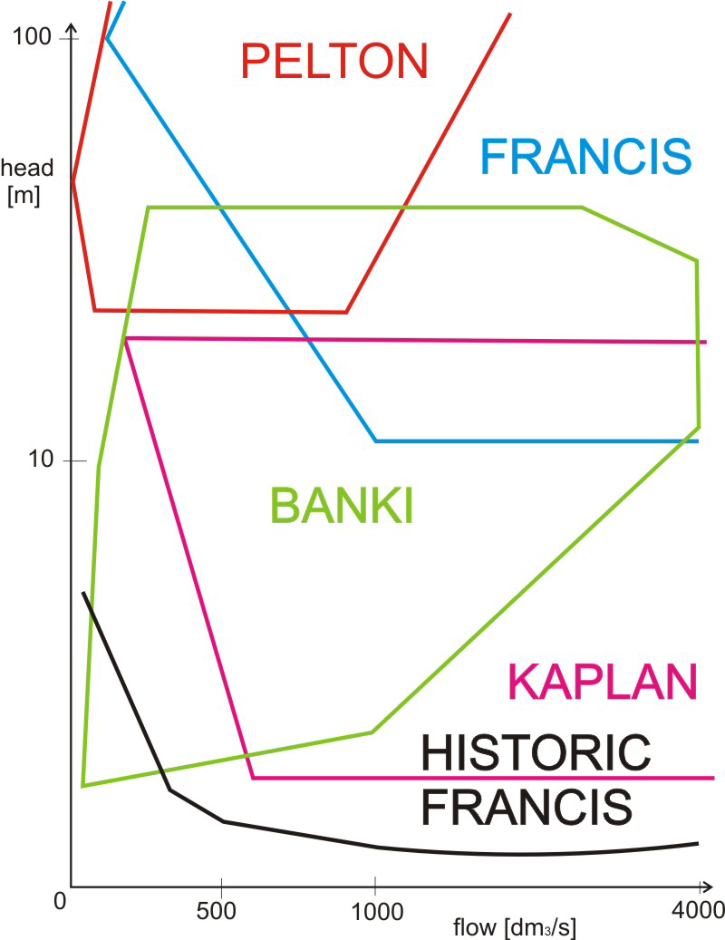
Fig. 9.9.: Utilisation range of turbines
Basic numerical parameter characterizing the type of turbine is the velocity rate that depends on speed triangles in the turbine. Specific power revolutions can be derived from the velocity rate φ and depends on the real revolutions n, the efficiency η, the flow Q and the specific energy E that depends on the head h and temperature.
$n_{s}=\text{1200}⋅n⋅\frac{\sqrt{Q}}{\sqrt[4]{E^{3}}}⋅\sqrt{η}=\text{1200}⋅n⋅\frac{\sqrt{Q}}{\sqrt[4]{{\left(2\text{gh}\right)}^{3}}}⋅\sqrt{η}$ [-] [9.11.]
Turbine | Utilized head  [m] | Specific power revolutions  [-] | Specific volume revolutions  [-] | Thom cavitation factor  [-]
Pelton | 2 – 2000 | 12 – 70 | 4 – 15 | 0
Banki | 1,5 – 100 | 35 – 220 | 12 – 60 | 0
Francis | 2 – 600 | 80 – 350 | 25 – 100 | 0,01 – 0,2
Deriaz | 2 – 70 | 300 – 400 | 85 – 115 | 0,2 – 0,6
Kaplan | 2 – 70 | 350 – 1200 | 100 – 300 | 0,6 – 3

Fig. 9.10.: Specific revolutions of turbines

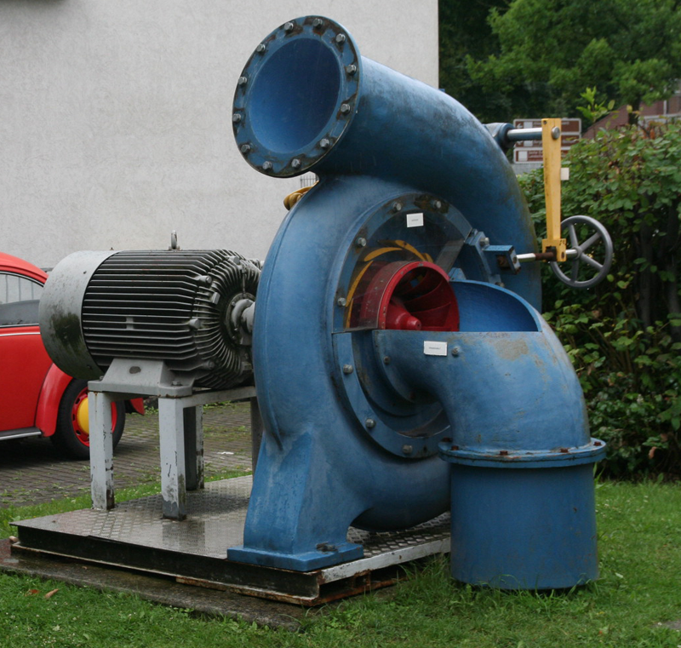

Fig. 9.11.: Francis turbine for small hydro power station

Cavitaion is a very complex and unpleasant mechanical process that can seriously damage organs of the turbine. Bubbles of water evaporate in a place with lower pressure than the pressure of saturised steam and dissolve (implode) in a place with higher pressure. This implosion is accompanied with intensive pressure strokes what causes high mechanical stresses of the organs. The nonhomogenous environment in the water contributes to electrochemical corrosion. The cavitation occurs mostly on the runner and depends on the type of turbine, revolution speed and pressure conditions such as head and air pressure and temperature.

Main conditiont to avoid the cavitaion is sufficient specific pressure energy higher than specific energy of saturised steam. Such that, maximum sucking depth can be approximately calculated from the air pressure p_{a}, head H and Thom cavitaion factor σ_{T}.
$H_{S}=\frac{p_{a}}{ρ⋅g}−σ_{T}⋅H$ [m] [9.12.]

9.3 Features of the water
Hydrologic cycle is the main engine for all hydro power stations. Notice, that the primary energy source for the cycle is the Sun and the Earth’s gravitation. The solar radiation heats the Earth’s surface and evaporates the water. Next, winds transport the vapors that later condense. And finally the gravitation evokes it to fall down on the surface as rain. If the drops fall to higher situated locations, their potential or kinetic energy can be later utilized in hydro power stations. Hydro energy belongs to inexhaustible or renewable energies.
The water is a carrier of mechanical energy, heat and chemical energy. The most important feature for power engineering is the mechanical energy of water streams that can be utilized as potential or kinetical energy.
The hydro energy is probably the longest utilized energy. Hydro power sources are widely used and belong to the largest energy plants. Considerable disadvantage is occupation and submersion of large area that can affect natural, historical and habitated places. Also the ship transport can be restricted or disabled.

9.4 Energy potential of the water stream
Theoretical energy potential of the stream is defined as the work necessary for transportation of a liquid from A to B and is equal to the difference of potential energy in A (W_{A}) and B (W_{B}) expressed as the elevation difference (head) h. The gravitation field is approximately constant (g). The practical temperatures are very close, so that the liguid density ρ is also a constant and the mass m can be substited with the volume V.
$W=W_{A}−W_{B}=m⋅g⋅h=V⋅ρ⋅g⋅h$ [J] [9.13.]
Theoretical power of the stream is defined as the work during the time τ. The volume during the time can be expressed as the flow Q. It is calculated for average flow Q_{50%} and flow 95% of maximum Q_{95%}.
$P=\frac{E}{τ}=\frac{V⋅ρ⋅g⋅h}{τ}=\frac{V}{τ}⋅ρ⋅g⋅h=Q⋅ρ⋅g⋅h$ [W] [9.14.]
Usable energy potential of the stream is the theoretical potential reduced of the losses during the energy conversions. Geological, hydrological, topological and economical conditions also reduce the utilizable energy.
The upper reach is usually characterized with higher gradient and lower flow, while the lower reach is typical with low gradient but high flow. There are just few localities in the nature with natural concentration of the gradient and the flow, such as water falls (Niagara Falls, Iguazu Falls, etc.). Usually it is necessary to concentrate the flow and the gradient (head) artificially with some swelling device.

9.4.1 Flow duration curve
The flow of a stream is usually unstable during a period. This unstability can be expressed as a flow duration curve.
The flow duration curve is mathematically a cumulative frequency curve that shows the percent of time during which specified flows or discharges were equaled or exceeded in given period. The flow duration curve is the integral representation of the frequency diagram of the flow or discharge. The flow duration curve doesn’t show the chronological sequence of the flow or discharge. The curve only shows when the flow was equaled or exceeded the specific limits.
If the time period, on which the flow duration curve is based, represents the long term of the flow or discharge, the curve may be considered as a probability curve and be used to estimate the flow. The time period shoud be several years (at least 3) long for some serious utilization.
Not total amount of water can be utilized for technical purposes. Sanitation flow Q_{s} must always bypass the hydro power station from the environmental reasons. This amount is usually defined as minimum flow in the most watery 330 days (Q₃₃₀).
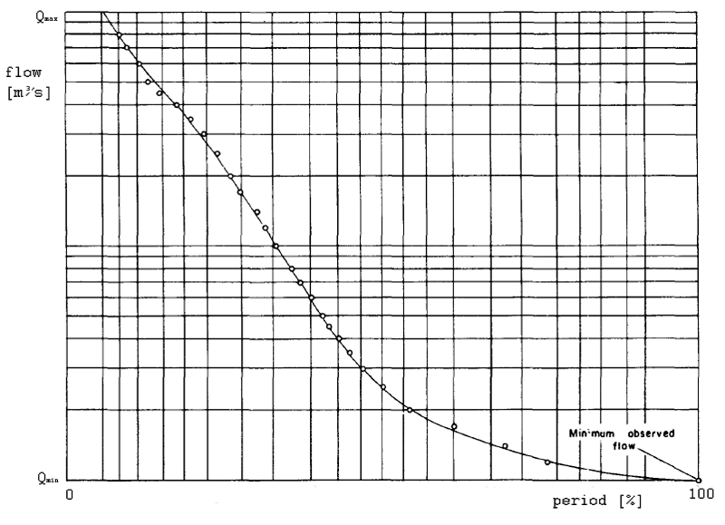Fig. 9.12.: Flow duration curve

11.4 Exercise
- Explain the origin of the hydro energy.
- Explain the term “theoretical energy potential of water stream”.
- Explain the term “flow duration curve”.
- Categorize the hydro power plants according to the operation mode.
- Categorize the swelling devices.
- Explain advantages and disadvantages of water wheels and turbines.
- Calculate the dimensions of a water wheel for flow Q = 1 m³s⁻¹ and head h = 1 m.
- Categorize the basic types of utilized turbines according to head.
- Project the turbine for small hydro power station in a location with average atmosphere pressure p_{a} = 95 kPa for utilisable head H = 3,2 m and flow Q = 1,01 m³s⁻¹. The turbine should have operational revolutions n = 200 rpm.
- Calculate annual production in hydro power plant. Utilized turbine has constant efficiency 75 % and the regulation range Q_{min} = 1,2 m³s⁻¹ and Q_{max} = 2,8 m³s⁻¹. The head is h = 2 m and flow duration curve is in the table on Fig. 9.10.
n [days] | 30 | 60 | 90 | 120 | 150 | 180 | 210 | 240 | 270 | 300 | 330 | 365
Q [m3/s] | 4,3 | 3,8 | 3,5 | 3,1 | 2,8 | 2,1 | 1,9 | 1,8 | 1,3 | 0,9 | 0,6 | 0,3

Fig. 9.13.: Table of flow duration curve

11.5 Answers
- The water carries mechanical energy, heat and chemical energy. The most important for power engineering is the mechanical energy of water streams. This energy is a result of the hydrologic cycle. Solar radiation heats the surface of the Earth and evaporates the water, winds transport the vapors, vapors later condense and fall down on the surface because of the gravitation. Their potential or kinetic energy can be utilized in hydro power stations. Hydro energy belongs is one of renewable energies.
- Theoretical energy potential of the stream is the work necessary for transportation of water from A to B and is equal to the difference of potential energy in A and B. It depends on the elevation difference (head) h, volume of the water V, gravitaion constant (g) and density of water ρ.
- The flow duration curve is a cumulative frequency curve that shows the percent of time during which specified flows or discharges were equaled or exceeded in given period. The flow duration curve is the integral representation of the frequency diagram of the unstable flow in the stream and doesn’t show the chronological sequence of the flow.
- Conventional hydro power station utilizes approximately total amount of the flow equally during the time. They have a reservoir that can be utilized for the regulation purpose (pondage run of the river plant) or don’t have any reservoir (nonpondage run of the river). Accumulation hydro power station uses some reservoir to accumulate the water during the non peak period and during the peak they utilize the accumulated water is utilized for electricity production. Pumped storage hydro power stations don’t produce electricity, but are used to store the energy during the non peak period, for covering the peaks. The plant has usually two reservoirs with some gradient.
- Large power station utilizes gravitational a dam built from rock fill or concrete dam. Small power stations utilize a weir or a derivational canal (wihout reservoir).
- Water wheels are the oldest and most primitive impulse engines, while turbines are usually high speed reaction machines (except Pelton and Banki) Wheels have very robust construction with a simple runner, while turbines utilize two sets of blades (distribution blades and runner). Wheels are not sensitive for mechanical impurities (sticks, leaves, ice drift, etc.) or variable water level (including floods and droughts), but have smaller efficiency than turbines. Wheel is a low speed machine and can be operated at vanishing head (only fast flowing water).
- According to equation 9.1., the diameter is choosen D = 5 m. Calculate according to equations 9.2., 9.3., 9.4., 9.5., 9.6., 9.7., 9.8. The parameters are following: revolution speed: 6,72 rpm, paddle width: 2,21 m, paddle depth: 0,53 m, paddle spacing: 0,49, number of paddles: 31.
- Smallest head: Kaplan, universal range: Francis, highest head: Pelton.
- Turbine should operate in small hydro power plant, so that efficiency could be estimater approximately 75 %. Calculate the specific power revolutions according to equation 9.11.: n_{s} = 263,2. According to table on Fig. 9.10., choose the Francis turbine. Now, check the the choosen turbine for cavitaiton. Use equation 9.12.: Hs = 9,04 m. Utilized head (3 m) is lower than maximum sucking depth (9,04 m), no cavitaition should be expected, turbine is choosen correctly.
- Sanitation flow is equal to Q₃₃₀ = 0,6 m³/s⁻¹. Utilisable flow Q_{u} is the flow Q reduced of sanitation flow Q₃₃₀. Flow through the turbine Q_{t} is utlilisable flow Q_{u}, restricted to regulation range of the turbine. Power of turbine P_{t} is calculated according to equation 9.14. and the efficiency in the table on Fig. 9.14. The annual energy is the sum of partial results.
n [days] | 30 | 60 | 90 | 120 | 150 | 180
Q [m3/s] | 4,3 | 3,8 | 3,5 | 3,1 | 2,8 | 2,1
Qu [m3/s] | 3,7 | 3,2 | 2,9 | 2,5 | 2,2 | 1,5
Qt [m3/s] | 2,8 | 2,8 | 2,8 | 2,5 | 2,2 | 1,5
Pt [kW] | 41,2 | 41,2 | 41,2 | 36,8 | 32,4 | 22,1
E [kWh] | 29655,4 | 29655,4 | 29655,4 | 26487,0 | 23308,6 | 15892,2
n [days] | 210 | 240 | 270 | 300 | 330 | 365
Q [m3/s] | 1,9 | 1,8 | 1,3 | 0,9 | 0,6 | 0,3
Qu [m3/s] | 1,3 | 1,2 | 0,7 | 0,3 | 0 | 0
Qt [m3/s] | 1,3 | 1,2 | 0 | 0 | 0 | 0
Pt [kW] | 19,1 | 17,7 | 0 | 0 | 0 | 0
E [kWh] | 13773,2 | 12713,8 | 0 | 0 | 0 | 0
Fig 9.14.: Calculation of annual energy production
The annual energy production can be 181171,1 kWh.

