10 Solar power systems

Keywords: solar energy, solar radiation, intensity, sun shine period, passive solar system, active solar system, solar power plant, photovoltaic power plant.

10.1 Solar power systems
The mankind uses the solar energy in many ways. Except the direct utilization for electricity or heat production, the solar energy is often utilized in an indirect way as some metamorphosed form of energy. Every fossil fuel is just a stored solar energy. That energy had incidented Earth’s surface millions years ago, was transformed through the photosynthesis to the chemical energy of a biomass and later stored under the surface and transmuted into coal, oil or gas. The mechanical energy of the wind is also just solar energy stored as heat in atmospherical layers. And finally, water cycle is also powered by sun that heats, evaporates and transports the water.

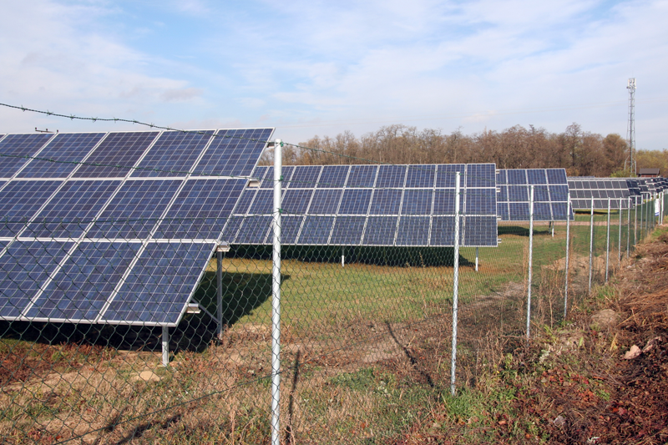

Fig. 10.1.: Dubnany photovoltaic power station
Direct utilization of solar radiation can be further classified on active and passive systems.
10.1.1 Passive solar systems
Passive solar systems are designed to work in harmony with the nature. It means, in fact, the clever use of different windows, shadings and insolations. Ancient and historial objects often meet these modern principles (prehistorical cottages, colonial architecture, etc.).
- solar architecture
  - positions of the object
  - sun decks, pergolas, winter gardens
  - shadings, roller blinds, roller tops
  - solar window
  - Trombe wall
  - solar foreside
- low energy objects
- passive objects

Active solar systems are special devices for some conversion of solar energy.

Fig. 10.2.: Solar architecture (Charleston)
10.1.2 Active solar systems

Active solar systems are special technical devices for some conversion of solar energy. The energy is usually converted into the heat or electricity, but many new nonconventional ways are under research.
- low temperature solar thermal systems
- high temperature solar thermal systems
- photovoltaic systems
- artifitial photosynthesis

10.2 Low temperature solar thermal systems
Low temperature solar thermal systems are utilized for heating, preheating, heating the supply water and heat accumulation. These systems usually consist of few collectors, an accumulator and fittings with regulation.
Absorber is a device for solar energy absorption. It can be simultaneously the accumulator of absorbed energy. Absorber is usually very primitive and doesn’t have any insolation or improvements for higher efficiency.
Collector is, in fact, an improved absorber. Absorber is usually an integral part of the collector. Additional insolation and improvements increase the efficiency. According to insolation, collectors are categorized as flat collectors, flat vacuum collectors and tube vacuum collectors.
Heat calculation of this system results from the calorimetric equation, where c_{p} is the heat capacity of used medium, t₁ means the temperature at the beginning, t₂ means the temperature at the end, difference and m is the weight of used media.
$Q=m⋅c_{p}⋅(t_{2}−t_{1})$ [J] [10.1.]

The heat Q must be supplied from the solar radiation I on the surface of the absorber S during the time τ.
$I⋅S⋅τ=m⋅c_{p}⋅(t_{2}−t_{1})$ [J] [10.2.]

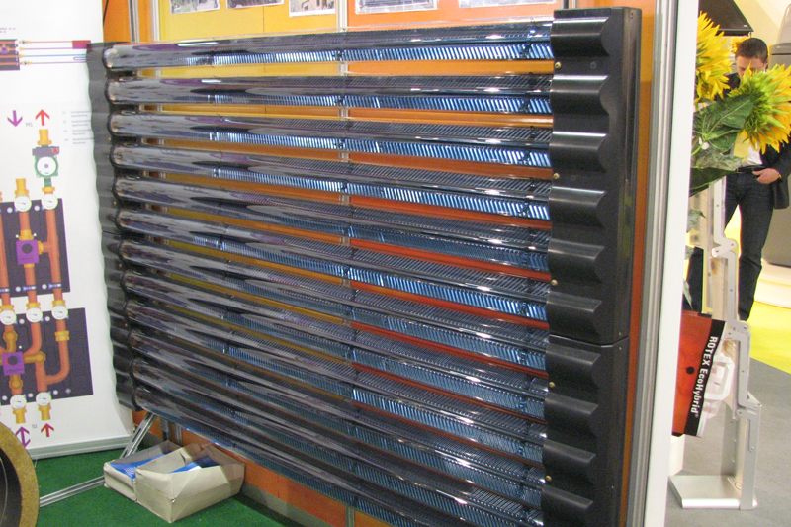
Fig. 10.3.: Vacuum tube collector

10.3 High temperature solar thermal systems
High temperature solar thermal systems are utilized for high temperature industrial heating or for steam generation. The generated steam powers normal steam turbine with generator. These units can be supported with conventional thermal power station to equalize the load chart and to optimize the produced energy.
Tower solar power station has one central absorber. A large set of reflecting devices – heliostats reflects incidenting solar radiation and focuses it into focal point. Incidenting radiation is considerably multipled and can reach the flow about 1 000 kW/m². Critical issue of this design is absolutely precise positioning and sun tracking of the heliostats. The heliostats are very sensitive on mechanical and thermal stress. The absorber is installed in the focal point and can directly serve as the steam generator.

The heat flow on the absorber’s surface A must be equal to reflected solar radiation I from the surface of the heliostats S with albedo r.
$I⋅S⋅r=q⋅A$ [J] [10.3.]

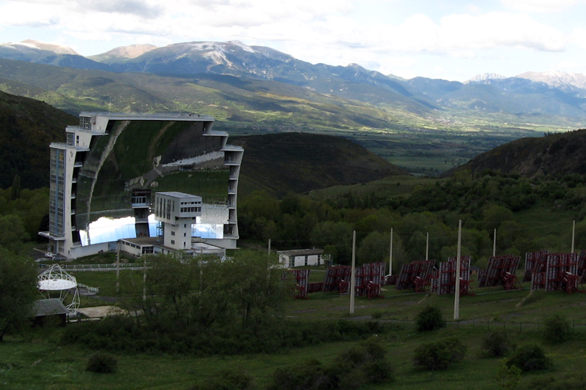
Fig. 10.4.: Odeillo Solar Furnace (France) – tower solar plant
Tower solar high temperature systems may be used not just for power enginnering, but also for various industrial purposes, such as material melting, heat stress test, etc.
Park solar power station has also a large set of reflecting devices – concentrators. Concentrators multiple and focus the incidenting radiation into their local focal points. Collecting pipelines collect and transfer the heat from the local focal points into one central steam generator. The heat flow is lower then in previous case and also working temperatures are lower, what limits the usage for industrial heating. Two circuit design also means lower efficiency of the power station. Main benefit is absence of complicated heliostats. The concentrators are not so sensitive on mechanical and thermal stress as the heliostats.
Either tower solar power stations or park solar power stations need strong direct solar radiation and long periods of the sunshine for reliable and effective operation. This fact limits the usage only on very pleasant locations in subtropical and tropical zone such as California, Nevada, Sahara, etc. These sources are practically disqualified for operation in Czech Republic, where the sunshine periods are quite short and also the direct radiation is considerably limited. Economical situation makes this power source obsolete. Photovoltaic installations are more profitable nowadays.

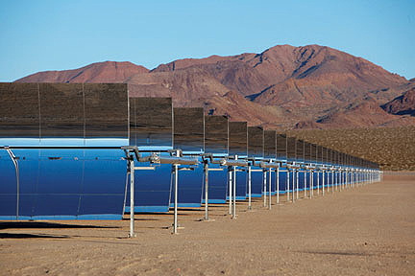

Fig. 10.5.: Nevada Solar One - park solar thermal power station

10.4 Photovoltaic systems
Photovoltaic systems utilize the photovoltaic effect for direct electricity production. Absorbed photon transfers its energy quantums to a valence electron. If the energy is sufficient to overcome the energy gap between the valence and conductance orbits, the electron is excited onto conductance orbit and can further be utilized in an electrical circuit.
Photovoltaic cell is a device using the photovoltaic effect. Output voltage depends on utilized material (its energy gap) and the output current depends on the size of the cell and the incidenting radiation.
Photovoltaic cells are measured and tested according to Standard Testing Conditions (STC):

spectrum AM 1,5 (daylight spectrum),

radiation intensity 1 000 W/m² (full sun),

temperature of the cell 25 °C.
VA characterisitic of photovoltaic cell describes basic features of the cell. Maximum power point is the optimal operating point and is usually situated in the bend of the curve. Quality cells have the bend very steep.

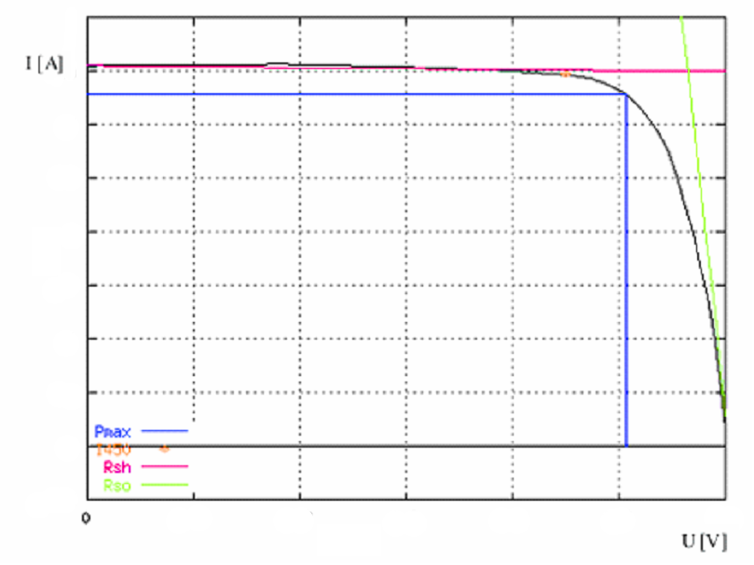

Fig. 10.6.: VA characteristics of monocrystalline silicon cell

Basic parameters of the photovoltaic cells are:

I450 - reference current at output voltage 450 mV [A]

Isc – short circuit current [A]

Uoc – open circuit voltage [V]

Pm - maximal power [W]

Im – current at point of maximal power [A]

Um – voltage at point of maximal power [V]

FF - Fill Factor – quality parameter [-]
$\text{FF}=\frac{\text{Im}\text{Um}}{\text{IscUoc}}$ [-] [10.4.]

E_{ef} - efficiency [%]

R_{so} – serial resistance [Ω]

R_{sh} - parallel shunt [Ω]

The VA characterisc depends on the solar radiation as on the power source. The higher is the intensity, the higher is the output current, because the amout of excited electrons is adequate to amount of incidenting photons.

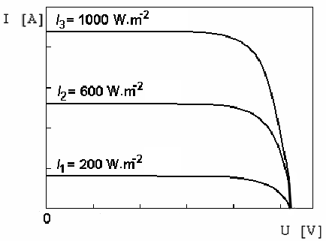

Fig. 10.7.: Dependence of VA characterstic on solar radiation

Higher temperature also increases the output current, because the energy necessary to overcome the energy gap is lower, but decreases the output voltage, because the resistance of the material is higher.

Photovoltaic panels with different output voltages and powers are constructed from the photovoltaic cells in serial – parallel connection. The cells are laminated between 2 layers and protected under overhead glass. Panels are framed for assembly. Bypass diods are often used to equalize unmatched, affected or faulty panels.
Tracker is a technical device that allows the panels to track the Sun what can increase the energy production. Trackers can be 1-axis or 2-axis. Tracking can depend on the Sun position or can be controlled with a timer. Seasonal manual repositioning of the panels is a simple compromise between the fixed system and the tracking system.
Concentrator is a technical device that concentrates the radiation on the panel, what can increase the energy production. The concentrator can consist of mirroring surfaces or focusing lenses.

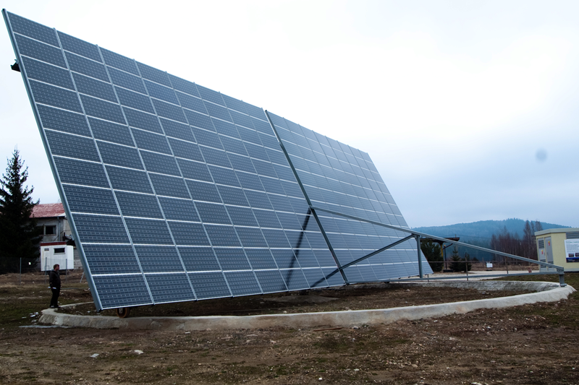

Fig. 10.8.: Strasice – tracking photovoltaic power station

Grid connected installation is a photovoltaic system that supplies produced energy into a public grid. This installation needs an inverter capable for synchronizing.
Stand alone installation is a photovoltaic system that usually supplies produced energy into an accumulator. Battery charger and inverter (not capable for synchronizing) are usual components of this system.

Photovoltaic cell can be categorized into generations according to utilized material and technology.
1st generation uses monocrystalline silicon, the oldest and most common material for photovoltaic cells. Sillicon as material is generally available, relatively cheap, non toxic, stable and has sufficient energy gap. Commercial cells reach the efficiency about 18 %. Maximal theoretical efficiency is 32 % and is described as Shockley-Queisser limit. Cheaper option is polycrystalline silicon that is cheaper in production. But lower efficiency compensates the economical benefits. These cells are mostly used in present photovoltaic power plants.
2nd generation is characterized with the effort of material savings. The cells use different and cheaper material as supporting substrat. Microcrystalline or amorphous silicon is used only as the absorber in a thin layer. These cells are relatively very cheap, but have relatively very low efficiency. These cells are sometimes utilized in low end photovoltaic systems.
3rd generation deals with different materials and different technologies. The goal is to increase the efficiency and to overcome the Shockley-Queisser limit. Tandem cells, multilayer cells, thermofotovoltaic cells, quantum well cells, three dimensionl structure cells, organic cells, etc. are the most important trends under research. CdS, CdSe, GaInP, GaAs or Ge seems to be materials of the future. These cells have high efficiency, but are very expensive and available only as experimental devices.

10.5 Features of the solar radiation
10.5.1 Solar energy
Solar energy is defined as the energy incidenting the Earth’s surface from the Sun in form of photons on different frequencies.
Solar energy belongs to inexhaustible energies. Different definitions call the solar energy the most pure energy or the only energy with pleasant environmental approach.
Unfortunately, solar energy has some specific features making it very difficult for technical utilization:
- flow rate variability during the year,
- flow rate variability during the day,
- direct and diffuse light.
The maximal utilizable energy intensity is called the solar constant I₀ and can be measured at the edge of the atmosphere. This number is not, in fact, constant but depends on the actual position on the Earht’s orbit and on the actual solar activity.
I₀=1368 [W/m²] [10.5.]
Roughly 30 % of this energy flow is reflected or reradiated back to the space, so that only 1 000 W/m² incidents the Earth’s surface. Theoretical utilisable energy depends on the location and varies between 600 kWh/m² and 2 200 kWh/m² as displayed on Fig. 10.1. Real usable energy depends, except that, on the annual period of sun shine in the locality τ (300 – 3000 h).
$Q=\int_{τ_{1}}^{τ_{2}}{\text{Id}τ}$ [kWh/m²] [10.6.]
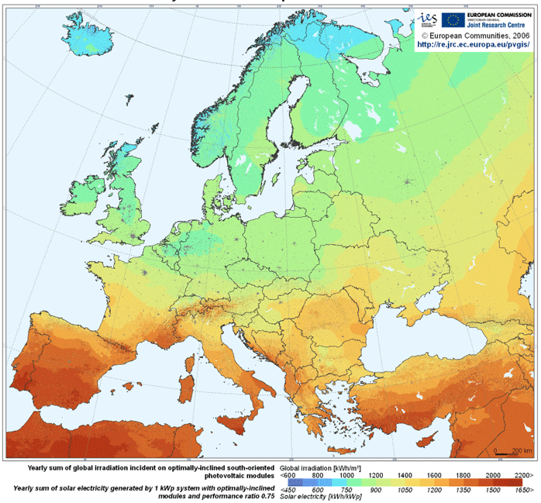 Fig. 10.9.: Solar energy potential

10.5.2 Intensity of solar radiation
Total intensity is defined as the summation of the direct light intensity I_{P} and the diffuse light intenzsity I_{D}.
$I=I_{P}+I_{D}$ [W/m²] [10.7.]
Direct light intensity can be calculated from the normal direct light intensity I_{PN} and the angle γ between the sun rays and insolated surface.
$I_{p} = I_{\text{Pn}} \text{cos} γ$ [W/m²] [10.8.]
Normal direct light intensity can be calculated from the solar constant I₀, the coefficient of the location ε and the atmosphere pollution coefficient Z.
$I_{\text{Pn}} = I_{0}e^{−\frac{Z}{ε}}$ [W/m²] [10.9.]
Coefficient of the location depends on the altitude of the location H and the angle of the Sun above the horizon h.
$ε = \frac{9,\text{38076} \left[\text{sin} h + {\left(0\text{.}\text{003} + {\text{sin}}^{2} h\right)}^{0\text{.}5}\right]}{2\text{.}\text{0015} \left(1− H ⋅ {\text{10}}^{−4}\right)} +0\text{.}\text{91018}$ [-] [10.10.]
Atmosphere pollution coefficient can be calculated according to the Linke’s equation from the solar constant I₀, normal direct light intensity at clean atmosphere I_{C} and normal direct light intensity at actual weather I_{N}.
$Z=\frac{\text{ln}I_{0}−\text{ln}I_{n}}{\text{ln}I_{0}−\text{ln}I_{Č}}$ [-] [10.11.]
Angle between the sun rays and insolated surface can be calculated from the angle of the Sun above the horizon h, the inclination of the surface α, azimuth of the surface a and azimuth of the sun a_{s}. The angle is calculated from the south in clockwise direction.
$\text{cos}γ=\text{sinh}\text{.}\text{cos}α+\text{coshsin}α\text{cos}(a−a_{s})$ [-] [10.12.]
Diffuse light intensity can be calculated from the inclination of the surface α, average albedo of surrounding surfaces r, the horizontal diffuse light intensity I_{Dh} and the horizontal direct light intensity I_{Ph}.
$I_{D}=0,5\left(1+\text{cos}α\right)I_{\text{Dh}}+0,5r\left(1−\text{cos}α\right) (I_{\text{Ph}}+I_{\text{Dh}})$ [W/m²] [10.13.]
Horizontal diffuse light intensity can be calculated from the solar constant I₀, the normal direct light intensity I_{PN} and the angle of the Sun above the horizon h.
$I_{\text{Dh}}=0,\text{33}\left(I_{0}−I_{\text{Pn}}\right)\text{sin} h$ [W/m²] [10.14.]
Normal direct light intensity can be calculated from the normal direct light intensity I_{PN} and the angle of the Sun above the horizon h.
$I_{\text{Ph}}=I_{\text{Pn}}\text{sin} h$ [W/m²] [10.15.]

Global radiation I_{G} refers to the total intensity, that incidents on the horizontal surface.

10.5.3 Sun shine period
Sun shine period is very fluctuating quantity and can be defined or measured as following quantities:
- astronomical sun shine is defined as the period, during that the Sun was above the non shaded horizon and no fog or cloudiness existed. It depends only on the location and ca be calculated as difference between the time of sunrise τ₂ and the sunset τ₁.
$τ_{a}=τ_{1}−τ_{2}$ [h] [10.16.]
- effective sun shine is defined as the astronomical sun shine τ_{a} abbreviated of the shading period from all existing natural and artificial obstacles τ_{s}.
$τ_{\text{ef}}=τ_{a}−τ_{s}$ [h] [10.17.]
- real sun shine is the quantity best usable in technical praxis, because the value is unpredictably affected with the weather and other circumstances in the locality. It can be only measured through heliographs or similar devices. (τ_{skut} [h]), která se získá měřením (např. heliografem). Odečet je
τ_{real} [h] [10.18.]
- average relative sun shine is an important parameter smoothing strong locality dependency of the real sun shine. It is defined as the ratio between the real sun shine τ_{real} and the effective sun shine τ_{ef}.
$τ'=\frac{τ_{\text{real}}}{τ_{\text{ef}}}$ [-] [10.19.]
Following charts display the real measured values of the solar radiation intensity and the sun shine period during an experimental service of the solar thermal system in Pilsen in 2003. Steep edges at the end of all charts predicate about some artifitial obstacle (wall) and the teeth on some daily curves demonstrate the influence of cloudiness. Monthly grapfhs show very vividly the average weather during the season. The area under each curve demonstrates the usable energe in each period (compare summer to winter).

Fig. 10.10.: Solar energy in winter day (Pilsen) – left suuny, right cloudy

Fig. 10.11.: Solar energy in summer day (Pilsen) – left suuny, right cloudy

Fig. 10.12.: Solar energy in winter season (Pilsen)

Fig. 10.13.: Solar energy in summer season (Pilsen)

10.6 Exercise
- Explain the term “solar constant”.
- Explain the difference between astronomical sun shine and effective sun shine.
- Characterise active solar systems. Name some examples.
- Explain the difference between absorber and collector in solar thermal systems.
- Calculate the heating process in primitive solar system consisting of large noninsulated tank as the absorber and the accumulator. The capacity is 200 l, insolated surface is 1 m², efficiency 30 %, time of heating is 8 hrs, average solar intensity 600 Wm⁻², and input temperature is 12 °C. What is the output temperature?
- Calculate the heating process in solar system consisting of collectors and insulated accumulator. The collectors surface is 2 x 1,7 m² and efficiency 60 %. Efficiency of the accumulator is 95 %. Time of heating is 8 hrs, average solar intensity 600 Wm⁻², input temperature is 12 °C and output temperature 50 °C. What is the amount of heated water?
- Explain the difference between tower solar power station and park solar power station.
- Draw the VA characteristic of a solar cell. Explain the term “standard testing conditions”.
- Describe the generations of solar cells.

10.7 Answers
- Solar constant I₀ is the maximal utilizable energy intensity measured at the edge of the atmosphere. I₀=1368 W/m².
- Astronomical sun shine is the period between the time of sunrise and the sunset. Efective sun shine is the astronomical sun shine abbreviated of the shading period from all existing natural and artificial obstacles.
- Active solar systems are special technical devices for solar energy conversion. The energy is usually converted into the heat or electricity. Active systems are e.g. solar thermal systems and photovoltaic systems.
- Absorber is a device for solar energy absorption, while collector is an improved device containing some additional insolation and other features increasing the efficiency.
- The equation 10.2. can be used for the calculation. Heat capacity of the water is c_{p} = 4187 J/kgK. The volume 200 l should be entered as 200 kg.
$t_{2}=\frac{I⋅S⋅τ}{m⋅c_{p}}+t_{1}$ [°C] [10.20.]
The output temperature of the heating, according to the calorimetric equation, is 18 °C.
- The equation 10.2. can be used for the calculation. Heat capacity of the water is c_{p} = 4187 J/kgK.
$m=\frac{I⋅S⋅τ}{c_{p}⋅(t_{2}−t_{1})}$ [kg] [10.21.]
The amount of heated water, according to the calorimetric equation, is 210 kg, what makes roughly 210 l.
- Tower solar power station has one central absorber and large set of reflecting devices (heliostats) reflecting and focusing incidenting solar radiation into focal point on the absorber, while park solar power station has large set of reflecting devices (concentrators) transferring the heat via collecting pipelines into central steam generator. The heat flow and working temperature is higher in the tower setup.

- VA characteristic is displayed on Fig. 10.6.
Standard testing conditions are defined with spectrum AM 1,5 (daylight spectrum), solar radiation intensity 1 000 W/m² (full sun) and temperature of the cell 25 °C.
- 1st generation of PV cells uses monocrystalline or polycrystalline silicon. These cells are standard nowadays.
2nd generation uses cheap material as supporting substrat and microcrystalline or amorphous silicon only as the absorber in a thin layer.
3rd generation deals with new materials and technologies to increase the efficiency.

