11 Wind power systems

Keywords: wind energy, wind speed, wind turbine, wind farm, horizontal axis wind turbine, vertical axis wind turbine, Darrieus, Savonius.

11.1 Wind power systems
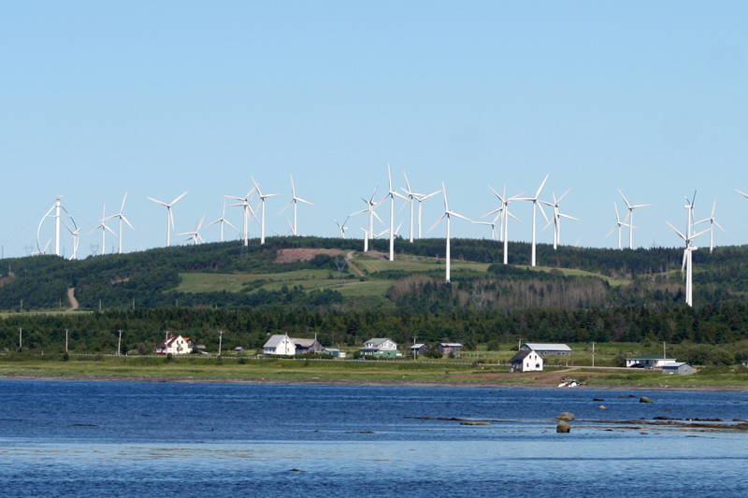
Wind turbines are often consolidated into wind farms consisting of hundreds or thousands units. Favourable locations, such as sea coasts, mountain passes, mountain ridges, etc. offer wind conditions with average speed over 9 ms⁻¹. Average wind speed in Czech Republic is approximately 4,5 ms⁻¹.
Fig. 11.1.: Cap Chat wind farm (Canada)
Unfortunatelly, wind turbines deal with badge of some controversy:

aesthetic impact on the landscape,

microclimate changes,

noise and low frequency noise,

bird kills,

stroboscopical effect,

dropping ice.

11.2 Wind engines
Wind engines convert the kinetic energy of the wind into mechanical energy of the shaft. There are two principles to perform this conversion.

11.2.1 Drag type rotors
Drag type rotors use the principle that wind constrains directly onto the blades and the blades with positive resistance develop a force.
Functionality is based on various resistance factor of the front and the back side of the blade. Various covers or curtains are often used to adjust the resistance. The vertical axis is also characteristic. These rotors usually can very good utilize low wind speeds, but cannot work on high wind speeds with sufficient efficiency.
Machines using this principle are the most simple and historically the oldest. They are usually used for small power or low end applications.
Savonius rotor uses 2 offset cylindrical convex blades. The blade offset serves as a regulation organ for various speeds.
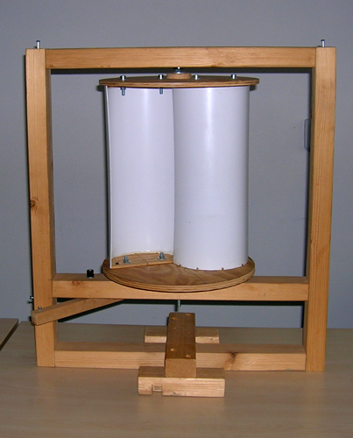
Fig. 11.2.: Savonius rotor (University of West Bohemia)
11.2.2 Lift turbines
Lift turbines use the upthrust force originating during the circumfluence of the blades. The blade must have an aerodynamical profile enabling circumfluence on different speed around the front and back side.
Turbines using this principle are all horizontal axis propellers and the vertical axis turbine Darrieus. Propellers can be regulated via the stall or pitch control, while Darrieus allows only stall (shape of the blades), what is difficult to design.
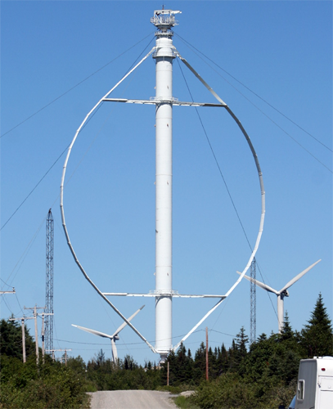
Fig. 11.3.: Darrieus rotor (EOLE – Canada)

11.2.3 Horizontal axis turbine
Horizontal axis turbine has a high tower to utilize higher wind speed in higher elevation above the terrain. A propeller powers a generator located in a slewing gondola. Some type of a rudder or counterballance is usually used for positioning the gondola to the wind. Circular movements of the gondola on the pylon make an issue for fetching out the electric power, because they can cause twisting the power cables.
Propellers have proved design and technology and these installations are the most common utilized in wind farms.
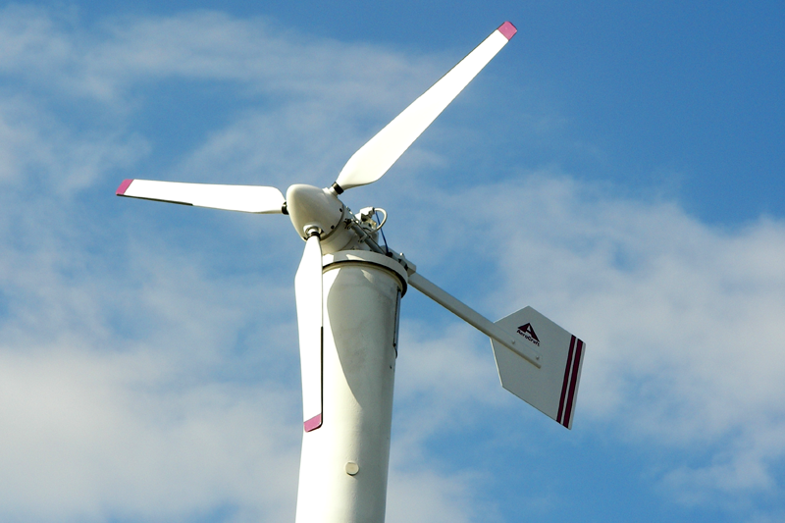
Fig. 11.4.: Horizontal axis turbine – propeller (University of West Bohemia)

11.2.4 Vertical axis turbine

Vertical axis turbine uses the pylon as the rotating axis. The generator can be simply installed in the basement, what avoids the issue of rotary gondolas of horizontal turbines. Actual blade position according to wind direction can make the start up difficult, so that these machines may use an auxiliary start.

The shape of blades and production technology are not experienced, so that these turbines make only marginal minority of all installations.

11.2.5 Power characteristic

Wind turbines need sufficient wind power for start up and their operation is limited at high speed from the security reasons. Modern turbines usually start at 4 – 5 ms⁻¹ and the security shut off usually comes at 20 - 25 ms⁻¹.

Low end wind turbines have no regulation and have fixed blades. More efficient controlled turbines use the stall or pitch control, what makes the power characteristic more flat, as displayed on Fig. 11.5. The shut off can be realized via a mechanical brake or via flagging the blades.

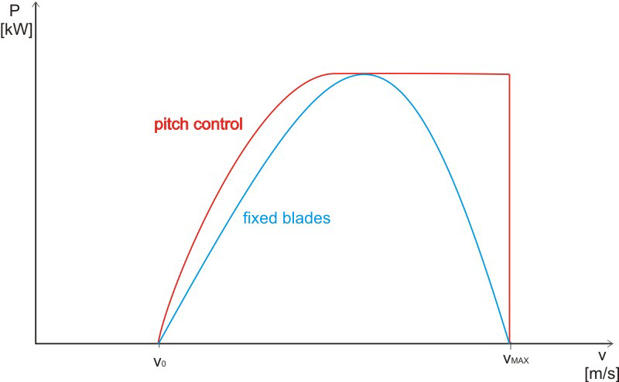
Fig. 11.5.: Power characteristic
Power of wind turbine can be derived from power of the wind (11.10.) with substitution of power factor c_{p}. A is the active surface of the wind turbine.
$P=\frac{1}{2}ρ⋅c_{p}⋅A⋅v^{3}$ [W] [11.1.]
Active surface depends on the type of the turbine. Every horizontal axis turbine has the active area equal to area of a circle. Vertical axis turbines have the active are equal to projection of their contour.
Power factor depends on the efficiency of the turbine type. Maximal real efficiency is limited and the terminal is called the Betz efficiency.
$η_{\text{betz}}=0,\text{5926}$ [-] [11.2.]
Velocity rate is defined as the ratio between peripheral speed u and the wind speed v. Peripheral speed can be calculated from turbine diameter d and rpm speed n.
$λ=\frac{u}{v}=\frac{π⋅d⋅n}{\text{60}⋅v}$ [-] [11.3.]
The wind speed is the most crucial parameter for turbine design. The higher is the nominal wind speed, the higher is the nominal power of the turbine. But the nominal wind speed must match the real wind conditions.
$v_{\text{no}\text{min}\text{al}}≤2,5⋅v_{\text{aver}}$ [11.4.]

11.3 Features of the wind
Wind is evoked during irregular heating of the Eart’s surface and further atmosphere layers above. There are few reasons of irregular heating. At first, surface is uneven insolated during the day and night, because of the Earth’s axis inclination, and beacuse of diverse cloudiness. Next, various parts of the surface have different absorption and heat capacity. Finally, the structure and morphology of the surface affects the heat transfer into the atmosphere. Pressure differencies originate between depressions and pressure heights. Lighter warm air raises up and heavier cold air is blown on its place.
Wind energy belongs to inexhaustible energies with origin in the Sun. Unfortunately wind energy has some specific features making it very difficult for technical utilization:
- unpredictable flow rate variability during the period,
- unpredictable and variable direction.

11.3.1 Wind speed and direction
The most important parametr characterizing the wind is actual wind speed. It can be directly measured with different types of anemometers (hot wire, bowl, etc.). This value is often complemented with actual wind direction.
Average wind speed can be calculated as arithmetical average of the actual wind speed records. This quantity is usually used for basic descriptions of wind capacity in a locality.
Predominating wind direction can be calculated from the actual wind direction records. This quantity is usually used as secondary description of wind capacity in a locality and is displayed as distribution chart.
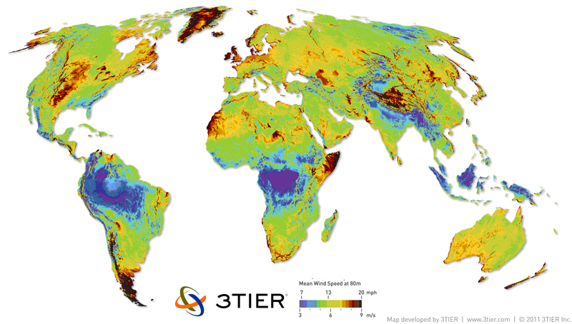Fig. 11.6.: Average wind speed at 80 m

The wind speed depends on the altitude because of the friction between atmosphere layers and the Earth’s surface. The speed v in the altitude h can be calculated from the reference speed v_{r} in reference altitude h_{r}. The surface morphology is described with the coefficient n, that can be found in tables.
$v=v_{r}{\left(\frac{h}{h_{r}}\right)}^{n}$ [ms⁻¹] [11.5.]
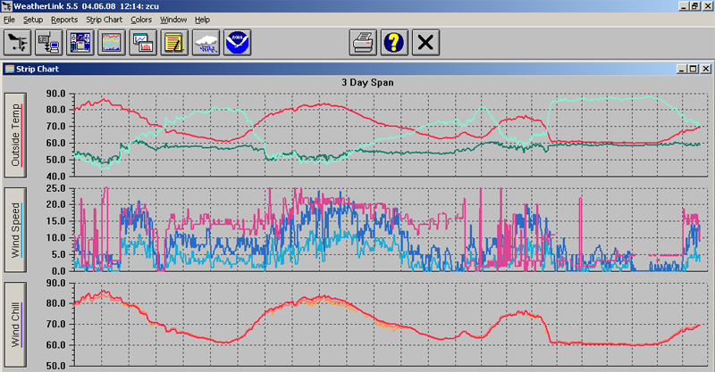Fig. 11.7.: Wind speed record

11.3.2 Wind energy
Wind energy can be calculated as the kinetic energy of the air mass with weight m moving on the speed v.
$E=\frac{1}{2}m⋅v^{2}$ [J] [11.6.]
The mass can be expressed from the volume V of the wind and the density ρ.
$m=V⋅ρ$ [kg] [11.7.]
The volume can be expressed as a solid defined with the base A and sagitta h.
$V=A⋅h$ [m³] [11.8.]
The sagitta is equal to the distance, that travel wind with speed v during unit time t.
$h=v⋅t$ [kg] [11.9.]
Theoretical wind power can be extracted from 11.6. through sequential substitution of 11.7., 11.8. and 11.9.
$P_{\text{theor}}=\frac{1}{2}ρ⋅A⋅v^{3}$ [W] [11.10.]

11.4 Exercise
- Explain the origin of the wind energy.
- What are the main disadvantages of the wind energy?
- What is the maximum real efficiency of a wind turbine?
- Explain the term “velocity rate”.
- What is the aerodynamical principle of the wind turbine Savonius?
- Calculate the theoretical wind power on unitary surface. Wind speed is v = 10 ms⁻¹ and air density ρ = 1,2 kgm⁻³.
- Compere annual production in 3 locations with different average speed (A = 4 ms⁻¹,B = 5 ms⁻¹ and C = 6 ms⁻¹). Power characteristic of the turbine is on the chart.
Speed [m/s] | Count [h]
Speed [m/s] | A | B | C
< 5 | 5764,1 | 4686,6 | 3810,6
5 | 928,6 | 946,1 | 928,6
6 | 657,0 | 779,6 | 805,9
7 | 473,0 | 630,7 | 683,3
8 | 332,9 | 481,8 | 560,6
9 | 227,8 | 350,4 | 446,8
10 | 148,9 | 262,8 | 359,2
11 | 96,4 | 201,5 | 280,3
12 | 52,6 | 140,2 | 219,0
13 | 35,0 | 96,4 | 166,4
14 | 17,5 | 61,3 | 140,2
15 | 17,5 | 43,8 | 96,4
16 | 8,8 | 26,3 | 70,1
17 | 0,0 | 26,3 | 61,3
18 | 0,0 | 17,5 | 43,8
19 | 0,0 | 8,8 | 26,3
20 | 0,0 | 0,0 | 17,5
> 20 | 0,0 | 0,0 | 43,8

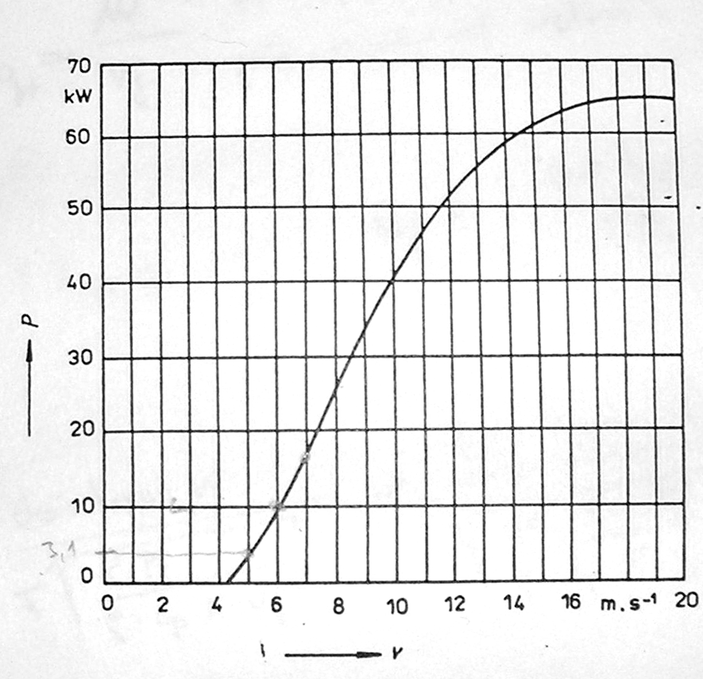

Fig. 11.8.: Table of wind speed in location A, B, C and power characteristic of the turbine

11.5 Answers
- Wind originates because of the irregular heating of the Eart’s surface and further atmosphere layers above. Pressure differencies between atmosphere depressions and preassure heights cause that lighter warm air raises up and heavier cold air is blown on its place.
- The main disadvantages of wind energy are the unpredictable variable flow rate and unpredictable variable direction.
- Maximal real efficiency is called the Betz efficiency and is 0,5926.
- Velocity rate is the ratio between peripheral speed of the blades and the wind speed.
- Savonius turbine utilizes the resistive principle. It means that wind constrains directly the blades with positive resistance developing a force.
- Equation 11.7. can be used for the calculation. Power factor c_{p} = 1 (theoretical value).
$P=\frac{1}{2}1⋅c_{p}⋅1⋅v^{3}$ [W] [11.11.]
The wind power is 600 W or 600 Wm⁻¹.

- Example calculation for the location B is demonstrated in the table. Power of the turbine and the wind speed can be read from the table and the power characteristic in Fig. 11.8. Total energy is the summarization of sectional amounts in Fig. 11.9.
Speed [m/s] | Power [kW] | Count [h] | Energy [kWh]
5 | 3,1 | 946,1 | 2932,8
6 | 8,9 | 779,6 | 6938,8
7 | 16,6 | 630,7 | 10470,0
8 | 25,1 | 481,8 | 12093,2
9 | 32,9 | 350,4 | 11528,2
10 | 40,2 | 262,8 | 10564,6
11 | 46,3 | 201,5 | 9328,5
12 | 51,0 | 140,2 | 7148,2
13 | 55,4 | 96,4 | 5338,3
14 | 58,6 | 61,3 | 3593,4
15 | 61,2 | 43,8 | 2680,6
16 | 63,0 | 26,3 | 1655,6
17 | 64,3 | 26,3 | 1689,8
18 | 65,0 | 17,5 | 1138,8
19 | 65,0 | 8,8 | 569,4
20 | 65,0 | 0,0 | 0,0
 |  | Total energy: | 87670,1

Fig. 11.9.: Calculation of annual production in location B
Annual energy production in the location B is 87 670 kWh.
Location A produces annually 50 080 kWh while location C produces annually 126 405 kWh.

